Part 1(Terraform Associate 004)

1. What command should be used to initialize a Terraform configuration that uses remote state?
terraform init
terraform apply
terraform plan
terraform validate
2. What tool can be used to automate Terraform workflows in a CI/CD pipeline?
Terraform Cloud
AWS Lambda
Ansible
Jenkins
3. Which of the following is the correct syntax to declare a variable in Terraform?
variable "example" { default = "value" }
var "example" = "value"
variable "example" = "value"
var "example" { default = "value" }
4. What is a Terraform module?
A collection of resources managed together
A provider configuration
A specific Terraform command
A temporary resource creation
5. What directive is used to load external configuration files in Terraform?
include
import
source
module
6. When would you use a data source in Terraform?
To manage state files
To fetch information from external sources
To define new resources
To store variable values
7. What does the `terraform_remote_state` data source allow you to do?
Import resources from other state files
Manage dependencies between modules
Reference outputs from another Terraform state
Modify the state of other resources
8. What is required to use HCP's Managed Terraform feature?
A dedicated server in your own data center
An HCP account
A valid Terraform license
An understanding of shell scripting
9. What does the `terraform state rm` command do?
Removes a resource from the Terraform state file
Creates a backup of the state file
Modifies a resource's configuration
Imports a resource into the Terraform state file
10. What is a key consideration when integrating Terraform with HCP?
Limiting access to network resources
Ensuring proper API authentication and authorization
Avoiding use of modules
Using only local execution of Terraform
11. What is the impact of using version control for Terraform configurations?
It reduces costs associated with Terraform usage
It allows for tracking changes and collaboration among team members
It simplifies the Terraform execution plan
It prevents the use of modules in Terraform
12. In the context of HCP integration, what does the acronym "HCP" stand for?
HashiCorp Platform
HashiCorp Cloud Product
HashiCorp Cloud Platform
Hybrid Cloud Platform
13. Which HashiCorp product is commonly managed using Terraform within HCP?
Consul
Vault
Nomad
All of the above
14. What is the function of the `terraform apply` command in terms of resource lifecycle?
It only verifies the configuration files
It destroys all existing resources
It creates, updates, or destroys resources according to the execution plan
It imports existing resources into the state
15. What is the primary benefit of using Terraform with HashiCorp Cloud Platform (HCP)?
Enhanced local storage
Simplified state management
Improved infrastructure scalability
Automated backup of local files
16. Which file stores the state of your Terraform-managed infrastructure?
terraform.tfstate
main.tf
variables.tf
backend.tf
17. How does HCP enhance collaboration among teams using Terraform?
Automatic coding style enforcement
Version control and shared state management
Pre-built Terraform modules
Graphical user interface for workflow management
18. Which command is used to validate a Terraform module's configuration syntax?
terraform init
terraform plan
terraform validate
terraform apply
19. What is the purpose of the `outputs.tf` file in a Terraform module?
To specify the version of Terraform used
To define the resources to be created
To provide outputs from the module that can be reused
To store provider configurations
20. How can Terraform work with HCP to manage secrets securely?
By using local variables
By integrating with HashiCorp Vault
By encrypting state files manually
By storing secrets in plaintext
21. What is a key advantage of using the HCP Terraform integration for infrastructure provisioning?
Local execution of resources
Direct integration with cloud providers like AWS
Managed services without needing local infrastructure
Increased manual configuration tasks
22. Which command would be used to destroy all resources defined in your Terraform configuration?
terraform destroy
terraform remove
terraform delete
terraform teardown
23. Which of the following is a required attribute for the AWS provider configuration?
region
access_key
secret_key
session_token
24. Which block is used to configure a provider in a Terraform file?
resource
module
provider
output
25. In a collaborative Terraform workflow, what is an advisable method for code reviews?
Review only the main configuration file
Implement automated tests before merging changes
Allow only one developer to make changes
Skip reviews to expedite the process
26. How can you configure multiple AWS providers in a single Terraform configuration?
By defining multiple `provider` blocks
By creating multiple state files
By using the `terraform workspace` command
By using the `count` argument in `resource`
27. Which command can be used to initialize a Terraform configuration and download necessary provider plugins?
terraform apply
terraform init
terraform plan
terraform validate
28. Which configuration would correctly override a variable's default value using a `terraform.tfvars` file?
example = "newValue"
variable "example" { default = "newValue" }
terraform { var="example:newValue" }
example: "newValue"
29. What command would you use to initialize a Terraform configuration that uses a new provider?
terraform apply
terraform validate
terraform init
terraform plan
30. What is the primary benefit of integrating Terraform with the HashiCorp Cloud Platform (HCP)?
Improved GUI for resource management
Automated scaling of resources
Simplified management and provisioning of HashiCorp products
Enhanced security with on-premises infrastructure
31. Which command can be used to safely transition between different versions of your Terraform configuration?
terraform init
terraform upgrade
terraform apply
terraform state
32. If a resource is created manually outside of Terraform, how can you bring it under Terraform management?
Use the `terraform import` command
Manually edit the state file
Use the `terraform apply` command
Remove the resource and recreate it in Terraform
33. What is the purpose of a Terraform backend?
To execute Terraform commands.
To store the state file securely.
To validate the configuration files.
To configure remote providers.
34. How can you share modules across different Terraform configurations?
By copying the module files manually
By using module repositories in version control systems like Git
By using only public modules from the Terraform Registry
By hardcoding module configurations
35. How can you pass custom authentication details to a provider in Terraform?
Through environment variables
Directly in the provider block
Using variable files
All of the above
36. What Terraform feature can be utilized alongside HCP for managing environment configurations?
Workspaces
Local modules
Backend state
Terraform CLI
37. Which HCP service is commonly used with Terraform for managing secrets?
HCP Vault
HCP Consul
HCP Nomad
HCP Terraform Enterprise
38. Which feature does HCP facilitate for Terraform users that aids in collaboration?
Monolithic configuration
Remote state storage
Local-only execution
Inline documentation
39. Why is it important to document your Terraform modules?
It is not important and can be skipped
To provide clarity and guidance for users of the module
To complicate the module usage
To reduce collaboration between team members
40. What is the effect of using the `terraform get` command?
It updates the remote backend configuration
It downloads or updates modules referenced in the configuration
It validates the syntax of the Terraform configuration files
It initializes the Terraform workspace

Part 2(Terraform Associate 004)
1. How can you trigger a run in a Terraform Cloud workspace that is connected to a Version Control System (VCS) repository?
Only Terraform Cloud organization owners can set workspace variables on VCS connected workspaces
Commit a change to the VCS working directory and branch that the Terraform Cloud workspace is connected to
Only Terraform Cloud organization owners can approve plans in VCS connected workspaces
Only members of a VCS organization can open a pull request against repositories that are connected to Terraform Cloud workspaces
2. Terraform providers are always installed from the Internet.
True
False
3. What kind of configuration block will create an infrastructure object with settings specified within the block?
provider
state
data
resource
4. What does state looking accomplish?
Prevent accidental Prevent accident deletion of the state file
Blocks Terraform commands from modifying, the state file
Copies the state file from memory to disk
Encrypts any credentials stored within the state file
5. In a Terraform Cloud workpace linked to a version control repository speculative plan rum start automatically commit changes to version control.
True
False
6. A Terraform provider is NOT responsible for:
Exposing resources and data sources based on an APUI
Managing actions to take based on resources differences
Understanding API interactions with some service
Provisioning infrastructure in multiple
7. How does the Terraform cloud integration differ from other state backends such as S3, Consul,etc?
It can execute Terraform runs on dedicated infrastructure in Terraform Cloud
It doesn't show the output of a terraform apply locally
It is only arable lo paying customers
All of the above
8. Which backend does the Terraform CLI use by default?
Depends on the cloud provider configured
HTTP
Remote
Terraform Cloud
Local
9. Which of these ate features of Terraform Cloud? Choose two correct answers.
Automated infrastructure deployment visualization
Automatic backups
A web-based user interface (Ul)
Remote state storage
10. Terraform variable names are saved in the state file.
True
False
11. You have provisioned some virtual machines (VMs) on Google Cloud Platform (GCP) using the gcloud command line tool. However, you are standardizing with Terraform and want to manage these VMs using Terraform instead.
What are the two things you must do to achieve this? Choose two correct answers.
Run the terraform Import-gcp command
Write Terraform configuration for the existing VMs
Use the terraform import command for the existing VMs
Provision new VMs using Terraform with the same VM names
12. When you use a remote backend that needs authentication, HashiCorp recommends that you:
Write the authentication credentials in the Terraform configuration files
Keep the Terraform configuration files in a secret store
Push your Terraform configuration to an encrypted git repository
Use partial configuration to load the authentication credentials outside of the Terraform code
13. What is the Terraform style convention for indenting a nesting level compared to the one above it?
With a tab
With two spaces
With four spaces
With three spaces
14. How does Terraform manage most dependencies between resources?
Terraform will automatically manage most resource dependencies
Using the depends_on parameter
By defining dependencies as modules and including them in a particular order
The order that resources appear in Terraform configuration indicates dependencies
15. You must use different Terraform commands depending on the cloud provider you use.
True
False
16. You cannot install third party plugins using terraform init.
True
False
17. Which of the following is not a valid Terraform variable type?
list
array
nap
string
18. You're building a CI/CD (continuous integration/continuous delivery) pipeline and need to inject sensitive variables into your Terraform run.
How can you do this safely?
Copy the sensitive variables into your Terraform code
Store the sensitive variables in a secure_var
tf file
Store the sensitive variables as plain text in a source code repository
Pass variables to Terraform with a -var flag
19. Module variable assignments are inherited from the parent module and you do not need to explicitly set them.
True
False
20. terraform validate confirms that your infrastructure matches the Terraform state file.
True
False
21. As a member of an operations team that uses infrastructure as code (lac) practices, you are tasked with making a change to an infrastructure stack running in a public cloud.
Which pattern would follow laC best practices for making a change?
Make the change via the public cloud API endpoint
Clone the repository containing your infrastructure code and then run the code
Use the public cloud console to make the change after a database record has been approved
Make the change programmatically via the public cloud CLI
Submit a pull request and wait for an approved merge of the proposed changes
22. Which command should you run to check if all code in a Terraform configuration that references multiple modules is properly formatted without making changes?
terraform fmt -write-false
terraform fmt -list -recursive
terraform fmt -check -recursive
terraform fmt -check
23. When should you write Terraform configuration files for existing infrastructure that you want to start managing with Terraform?
You can import infrastructure without corresponding Terraform code
Terraform will generate the corresponding configuration files for you
Before you run terraform Import
After you run terraform import
24. What does Terraform not reference when running a terraform apply -refresh-only ?
State file
Credentials
Cloud provider
Terraform resource definitions in configuration files
25. What does this code do?
terraform { required_providers { aws = ">= 3.0" }}
Requires any version of the AWS provider > = 3.0 and <4.0
Requires any version of the AWS provider >= 3.0
Requires any version of the AWS provider > = 3.0 major release. like 4.1
Requires any version of the AWS provider > 3.0
26. You have deployed a new webapp with a public IP address on a cloud provider. However, you did not create any outputs for your code.
What is the best method to quickly find the IP address of the resource you deployed?
In a new folder, use the terraform_remote_state data source to load in the state file, then write an output for each resource that you find the state file
Run terraform state list to find the name of the resource, then terraform state show to find the attributes including public IP address
Run terraform output ip_address to view the result
Run terraform destroy then terraform apply and look for the IP address in stdout
27. What feature stops multiple users from operating on the Terraform state at the same time?
State locking
Version control
Provider constraints
Remote backends
28. What information does the public Terraform Module Registry automatically expose about published modules?
Required input variables
Optional inputs variables and default values
Outputs
All of the above
None of the above
29. You want to define a single input variable to capture configuration values for a server. The values must represent memory as a number, and the server name as a string.
Which variable type could you use for this input?
List
Object
Map
Terraform does not support complex input variables of different types
30. You decide to move a Terraform state file to Amazon S3 from another location.
You write the code below into a file called backend.tf.
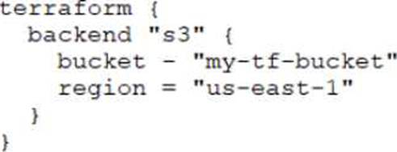
Which command will migrate your current state file to the new S3 remote backend?
terraform state
terraform init
terraform push
terraform refresh
31. Which parameters does terraform import require? Choose two correct answers.
Provider
Resource ID
Resource address
Path
32. A developer accidentally launched a VM (virtual machine) outside of the Terraform workflow and ended up with two servers with the same name. They don't know which VM Terraform manages but do have a list of all active VM IDs.
Which of the following methods could you use to discover which instance Terraform manages?
Run terraform state list to find the names of all VMs, then run terraform state show for each of them to find which VM ID Terraform manages
Update the code to include outputs for the ID of all VMs, then run terraform plan to view the outputs
Run terraform taint/code on all the VMs to recreate them
Use terraform refresh/code to find out which IDs are already part of state
33. You have never used Terraform before and would like to test it out using a shared team account for a cloud provider. The shared team account already contains 15 virtual machines (VM). You develop a Terraform configuration containing one VM. perform terraform apply, and see that your VM was created successfully.
What should you do to delete the newly-created VM with Terraform?
The Terraform state file contains all 16 VMs in the team account. Execute terraform destroy and select the newly-created V
Delete the Terraform state file and execute terraform apply.
The Terraform state file only contains the one new V
Execute terraform destroy.
Delete the VM using the cloud provider console and terraform apply to apply the changes to the Terraform state file.
34. Which of the following statements about Terraform modules is not true?
Modules can call other modules
A module is a container for one or more resources
Modules must be publicly accessible
You can call the same module multiple times
35. If you update the version constraint in your Terraform configuration, Terraform will update your lock file the next time you run terraform Init.
True
False
36. Why does this backend configuration not follow best practices?
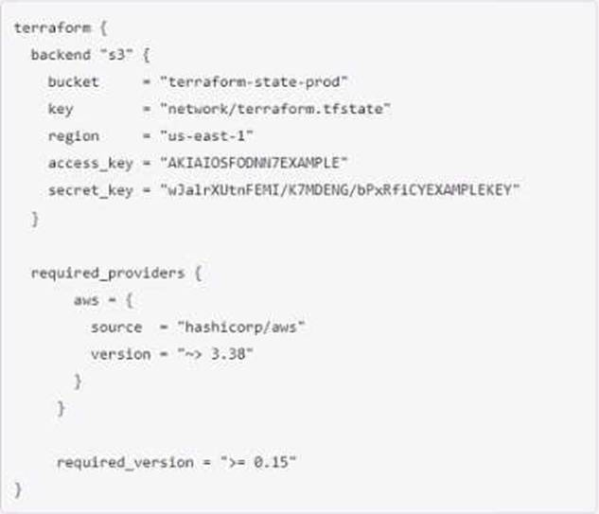
An alias meta-argument should be included in backend blocks whenever possible
You should use the local enhanced storage backend whenever possible
You should not store credentials in Terraform configuration
The backend configuration should contain multiple credentials so that more than one user can execute terraform plan and terraform apply
37. Outside of the required_providers block, Terraform configurations always refer to providers by their local names.
True
False
38. You can reference a resource created with for_each using a Splat ( *) expression.
True
False
39. Once you configure a new Terraform backend with a terraform code block, which command(s) should you use to migrate the state file?
terraform destroy, then terraform apply
terraform init
terraform push
terraform apply
40. 1.Module version is required to reference a module on the Terraform Module Registry.
True
False

Part 1(Terraform Associate 003)
1. A Terraform provider is NOT responsible for:
Exposing resources and data sources based on an APUI
Managing actions to take based on resources differences
Understanding API interactions with some service
Provisioning infrastructure in multiple
2. What feature stops multiple users from operating on the Terraform state at the same time?
State locking
Version control
Provider constraints
Remote backends
3. _______backends support state locking.
All
No
Some
Only local
4. Where does the Terraform local backend store its state?
In the terraform file
In the /tmp directory
In the terraform,tfstate file
In the user’s terraform,state file
5. In a Terraform Cloud workpace linked to a version control repository speculative plan rum start automatically commit changes to version control.
True
False
6. terraform validate confirms that your infrastructure matches the Terraform state file.
True
False
7. What type of block is used to construct a collection of nested configuration blocks?
Dynamic
For_each
Nesting
repeated.
8. You have created a main.tf Terraform configuration consisting of an application server, a database and a load balanced. You ran terraform apply and Terraform created all of the resources successfully. Now you realize that you do not actually need the load balancer, so you run terraform destroy without any flags.
What will happen?
Terraform will prompt you to pick which resource you want to destroy
Terraform will destroy the application server because it is listed first in the code
Terraform will prompt you to confirm that you want to destroy all the infrastructure
Terraform will destroy the main, tf file
Terraform will immediately destroy all the infrastructure
9. You have declared a variable called var.list which is a list of objects that all have an attribute id.
Which options will produce a list of the IDs? Choose two correct answers.
[ var.list [ * ] , id ]
[ for o in var.list : o.Id ]
var.list [*].id
{ for o in var.llst : o => o.id }
10. A module can always refer to all variables declared in its parent module.
True
False
11. When does Sentinel enforce policy logic during a Terraform Cloud run?
Before the plan phase
During the plan phase
Before the apply phase
After the apply phase
12. You ate making changes to existing Terraform code to add some new infrastructure. When is the best time to run terraform validate?
After you run terraform apply so you can validate your infrastructure
Before you run terraform apply so you can validate your provider credentials
Before you run terraform plan so you can validate your code syntax
After you run terraform plan so you can validate that your state file is consistent with your infrastructure
13. What does this code do?
terraform { required_providers { aws = ">= 3.0" }}
Requires any version of the AWS provider > = 3.0 and <4.0
Requires any version of the AWS provider >= 3.0
Requires any version of the AWS provider > = 3.0 major release. like 4.1
Requires any version of the AWS provider > 3.0
14. Which of the following is not a valid Terraform variable type?
list
array
nap
string
15. Which of the following command would be use to access all of the attributes and details of a resource managed by Terraform?
Terraform state show ‘ provider_type_name
Terraform state list
Terraform get provider_type_name
Terraform state list provider_type_name
16. Outside of the required_providers block, Terraform configurations always refer to providers by their local names.
True
False
17. You cannot install third party plugins using terraform init.
True
False
18. 1.Module version is required to reference a module on the Terraform Module Registry.
True
False
19. Setting the TF_LOG environment variable to DEBUG causes debug messages to be logged into stdout.
True
False
20. You're building a CI/CD (continuous integration/continuous delivery) pipeline and need to inject sensitive variables into your Terraform run.
How can you do this safely?
Copy the sensitive variables into your Terraform code
Store the sensitive variables in a secure_var
tf file
Store the sensitive variables as plain text in a source code repository
Pass variables to Terraform with a -var flag
21. You are using a networking module in your Terraform configuration with the name label my-network.
In your main configuration you have the following code:
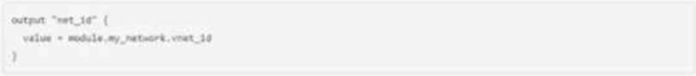
When you run terraform validate, you get the following error:
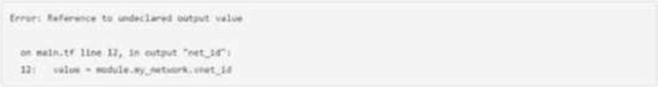
What must you do to successfully retrieve this value from your networking module?
Change the reference value to my-network,outputs,vmet_id
Define the attribute vmet_id as a variable in the networking modeule
Define the attribute vnet_id as an output in the networking module
Change the reference value module.my,network,outputs,vnet_id
22. Which command must you first run before performing further Terraform operations in a working directory?
terraform import
terraform workspace
terraform plan
terraform init
23. How does Terraform manage most dependencies between resources?
Terraform will automatically manage most resource dependencies
Using the depends_on parameter
By defining dependencies as modules and including them in a particular order
The order that resources appear in Terraform configuration indicates dependencies
24. Your DevOps team is currently using the local backend for your Terraform configuration. You would like to move to a remote backend to store the state file in a central location.
Which of the following backends would not work?
Artifactory
Amazon S3
Terraform Cloud
Git
25. What is one disadvantage of using dynamic blocks in Terraform?
Dynamic blocks can construct repeatable nested blocks
Terraform will run more slowly
They cannot be used to loop through a list of values
They make configuration harder to read and understand
26. You have never used Terraform before and would like to test it out using a shared team account for a cloud provider. The shared team account already contains 15 virtual machines (VM). You develop a Terraform configuration containing one VM. perform terraform apply, and see that your VM was created successfully.
What should you do to delete the newly-created VM with Terraform?
The Terraform state file contains all 16 VMs in the team account. Execute terraform destroy and select the newly-created V
Delete the Terraform state file and execute terraform apply.
The Terraform state file only contains the one new V
Execute terraform destroy.
Delete the VM using the cloud provider console and terraform apply to apply the changes to the Terraform state file.
27. What is the Terraform style convention for indenting a nesting level compared to the one above it?
With a tab
With two spaces
With four spaces
With three spaces
28. As a developer, you want to ensure your plugins are up to date with the latest versions.
Which Terraform command should you use?
terraform refresh -upgrade
terraform apply -upgrade
terraform init -upgrade
terraform providers -upgrade
29. You have provisioned some virtual machines (VMs) on Google Cloud Platform (GCP) using the gcloud command line tool. However, you are standardizing with Terraform and want to manage these VMs using Terraform instead.
What are the two things you must do to achieve this? Choose two correct answers.
Run the terraform Import-gcp command
Write Terraform configuration for the existing VMs
Use the terraform import command for the existing VMs
Provision new VMs using Terraform with the same VM names
30. Terraform providers are always installed from the Internet.
True
False
31. How would you reference the volume IDs associated with the ebs_block_device blocks in this configuration?
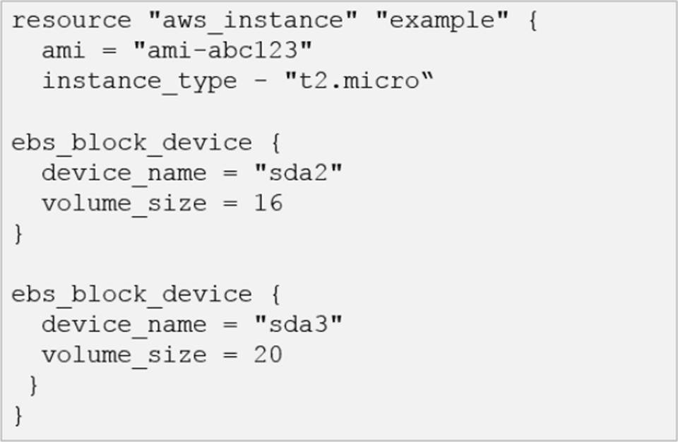
aws_instance.example.ebs_block_device [sda2,sda3).volume_id
aws_lnstance.example.ebs_block_device. [*].volume_id
aws_lnstance.example.ebs_block_device.volume_ids
aws_instance.example-ebs_block_device.*.volume_id
32. Which of the following is not a valid string function in Terraform?
chomp
join
slice
split
33. How can a ticket-based system slow down infrastructure provisioning and limit the ability to scale? Choose two correct answers.
End-users have to request infrastructure changes
Ticket based systems generate a full audit trail of the request and fulfillment process
Users can access catalog of approved resources from drop down list in a request form
The more resources your organization needs, the more tickets your infrastructure team has to process
34. Where can Terraform not load a provider from?
Plugins directory
Provider plugin chance
Official HashCrop Distribution on releases.hashcrop.com
Source code
35. What does state looking accomplish?
Prevent accidental Prevent accident deletion of the state file
Blocks Terraform commands from modifying, the state file
Copies the state file from memory to disk
Encrypts any credentials stored within the state file
36. What Terraform command always causes a state file to be updated with changes that might have been made outside of Terraform?
Terraform plan Crefresh-only
Terraform show Cjson
Terraform apply Clock-false
Terraform plan target-state
37. Variables declared within a module are accessible outside of the module.
True
False
38. What information does the public Terraform Module Registry automatically expose about published modules?
Required input variables
Optional inputs variables and default values
Outputs
All of the above
None of the above
39. You want to know from which paths Terraform is loading providers referenced in your Terraform configuration (* files). You need to enable additional logging messages to find this out.
Which of the following would achieve this?
Set verbose for each provider in your Terraform configuration
Set the environment variable TF_LOG_TRACE
Set the environment variable TF_LOG_PATH
Set the environment variable TF_log_TRACE
40. You have deployed a new webapp with a public IP address on a cloud provider. However, you did not create any outputs for your code.
What is the best method to quickly find the IP address of the resource you deployed?
In a new folder, use the terraform_remote_state data source to load in the state file, then write an output for each resource that you find the state file
Run terraform state list to find the name of the resource, then terraform state show to find the attributes including public IP address
Run terraform output ip_address to view the result
Run terraform destroy then terraform apply and look for the IP address in stdout

Part 2(Terraform Associate 003)
1. Which are examples of infrastructure as code? Choose two correct answers.
Cloned virtual machine images
Versioned configuration files
Change management database records
Doctor files
2. Which command add existing resources into Terraform state?
Terraform init
Terraform plan
Terraform refresh
Terraform import
All of these
3. What is the workflow for deploying new infrastructure with Terraform?
Write Terraform configuration, run terraform init to initialize the working directory orworkspace, and run terraform apply
Write Terraform configuration, run terraform show to view proposed changes, and terraform apply to create new infrastructure
Write Terraform configuration, run terraform apply to create infrastructure, use terraform validate to confirm Terraform deployed resources correctly
Write Terraform configuration, run terraform plan to initialize the working directory or workspace, and terraform apply to create the infrastructure
4. You decide to move a Terraform state file to Amazon S3 from another location. You write the code below into a file called backend.tf.

Which command will migrate your current state file to the new S3 remote backend?
terraform state
terraform init
terraform push
terraform refresh
5. Why does this backend configuration not follow best practices?
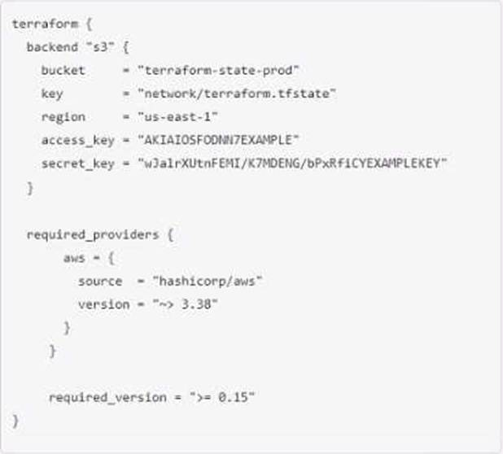
An alias meta-argument should be included in backend blocks whenever possible
You should use the local enhanced storage backend whenever possible
You should not store credentials in Terraform configuration
The backend configuration should contain multiple credentials so that more than one user can execute terraform plan and terraform apply
6. How does the Terraform cloud integration differ from other state backends such as S3, Consul,etc?
It can execute Terraform runs on dedicated infrastructure in Terraform Cloud
It doesn't show the output of a terraform apply locally
It is only arable lo paying customers
All of the above
7. When do changes invoked by terraform apply take effect?
After Terraform has updated the state file
Once the resource provider has fulfilled the request
Immediately
None of the above are correct
8. What does Terraform use the .terraform.lock.hc1 file for?
There is no such file
Tracking specific provider dependencies
Preventing Terraform runs from occurring
Storing references to workspaces which are locked
9. The public Terraform Module Registry is free to use.
True
False
10. Only the user that generated a plan may apply it.
True
False
11. How can you trigger a run in a Terraform Cloud workspace that is connected to a Version Control System (VCS) repository?
Only Terraform Cloud organization owners can set workspace variables on VCS connected workspaces
Commit a change to the VCS working directory and branch that the Terraform Cloud workspace is connected to
Only Terraform Cloud organization owners can approve plans in VCS connected workspaces
Only members of a VCS organization can open a pull request against repositories that are connected to Terraform Cloud workspaces
12. You want to define a single input variable to capture configuration values for a server. The values must represent memory as a number, and the server name as a string.
Which variable type could you use for this input?
List
Object
Map
Terraform does not support complex input variables of different types
13. As a member of an operations team that uses infrastructure as code (lac) practices, you are tasked with making a change to an infrastructure stack running in a public cloud.
Which pattern would follow laC best practices for making a change?
Make the change via the public cloud API endpoint
Clone the repository containing your infrastructure code and then run the code
Use the public cloud console to make the change after a database record has been approved
Make the change programmatically via the public cloud CLI
Submit a pull request and wait for an approved merge of the proposed changes
14. It is best practice to store secret data in the same version control repository as your Terraform configuration.
True
False
15. Terraform variable names are saved in the state file.
True
False
16. Which of the following statements about Terraform modules is not true?
Modules can call other modules
A module is a container for one or more resources
Modules must be publicly accessible
You can call the same module multiple times
17. You can develop a custom provider to manage its resources using Terraform.
True
False
18. If you update the version constraint in your Terraform configuration, Terraform will update your lock file the next time you run terraform Init.
True
False
19. What kind of configuration block will create an infrastructure object with settings specified within the block?
provider
state
data
resource
20. When should you write Terraform configuration files for existing infrastructure that you want to start managing with Terraform?
You can import infrastructure without corresponding Terraform code
Terraform will generate the corresponding configuration files for you
Before you run terraform Import
After you run terraform import
21. You ate creating a Terraform configuration which needs to make use of multiple providers, one for AWS and one for Datadog.
Which of the following provider blocks would allow you to do this?
A)
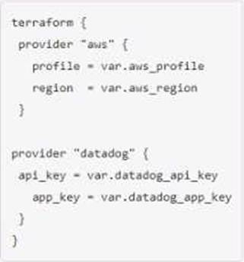
B)
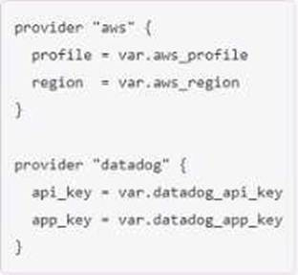
C)
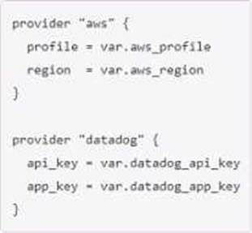
D)
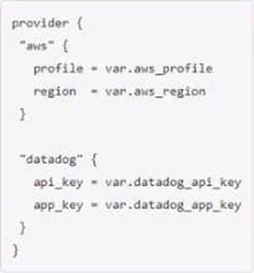
Option A
Option B
Option C
Option D
22. You must use different Terraform commands depending on the cloud provider you use.
True
False
23. Which of these ate features of Terraform Cloud? Choose two correct answers.
Automated infrastructure deployment visualization
Automatic backups
A web-based user interface (Ul)
Remote state storage
24. Module variable assignments are inherited from the parent module and you do not need to explicitly set them.
True
False
25. Which command should you run to check if all code in a Terraform configuration that references multiple modules is properly formatted without making changes?
terraform fmt -write-false
terraform fmt -list -recursive
terraform fmt -check -recursive
terraform fmt -check
26. Which of the following is not a valid Terraform collection type?
Tree
Map
List
set
27. Once you configure a new Terraform backend with a terraform code block, which command(s) should you use to migrate the state file?
terraform destroy, then terraform apply
terraform init
terraform push
terraform apply
28. What does the default "local" Terraform backend store?
tfplan files
State file
Provider plugins
Terraform binary
29. You have a Terraform configuration that defines a single virtual machine with no references to it, You have run terraform apply to create the resource, and then removed the resource definition you’re your Terraform configuration file.
What will happen you run terraform apply in the working directory again?
Terraform will remove the virtual machine from the state file, but the resource will still exist
Nothing
Terraform will error
Terraform will destroy the virtual machine
30. The_________determines how Terraform creates, updates, or delete resources.
Terraform configuration
Terraform provisioner
Terraform provider
Terraform core
31. When you use a remote backend that needs authentication, HashiCorp recommends that you:
Write the authentication credentials in the Terraform configuration files
Keep the Terraform configuration files in a secret store
Push your Terraform configuration to an encrypted git repository
Use partial configuration to load the authentication credentials outside of the Terraform code
32. Which of the following ate advantages of using infrastructure as code (laC) instead of provisioning with a graphical user interface (GUI)? Choose two correct answers.
Lets you version, reuse, and share infrastructure configuration
Provisions the same resources at a lower cost
Secures your credentials
Reduces risk of operator error
Prevents manual modifications to your resources
33. Which parameters does terraform import require? Choose two correct answers.
Provider
Resource ID
Resource address
Path
34. Which method for sharing Terraform configurations fulfills the following criteria:
1. Keeps the configurations confidential within your organization
2. Support Terraform’s semantic version constrains
3. Provides a browsable directory
Subfolder within a workspace
Generic git repository
Terraform Cloud private registry
Public Terraform module registry
35. When using multiple configuration of the same Terraform provider, what meta-argument must you include in any non-default provider configurations?
Alias
Id
Depends_on
name
36. You much initialize your working directory before running terraform validate.
True
False
37. What does Terraform not reference when running a terraform apply -refresh-only ?
State file
Credentials
Cloud provider
Terraform resource definitions in configuration files
38. Your security team scanned some Terraform workspaces and found secrets stored in plaintext in state files.
How can you protect that data?
Edit your state file to scrub out the sensitive data
Always store your secrets in a secrets.tfvars file
Delete the state file every time you run Terraform
Store the state in an encrypted backend
39. Running terraform fmt without any flags in a directory with Terraform configuration files check the formatting of those files without changing their contents.
True
False
40. A developer accidentally launched a VM (virtual machine) outside of the Terraform workflow and ended up with two servers with the same name. They don't know which VM Terraform manages but do have a list of all active VM IDs.
Which of the following methods could you use to discover which instance Terraform manages?
Run terraform state list to find the names of all VMs, then run terraform state show for each of them to find which VM ID Terraform manages
Update the code to include outputs for the ID of all VMs, then run terraform plan to view the outputs
Run terraform taint/code on all the VMs to recreate them
Use terraform refresh/code to find out which IDs are already part of state
41. How do you specify a module’s version when publishing it to the public terraform Module Registry?
Configuration it in the module's Terraform code
Mention it on the module's configuration page on the Terraform Module Registry
The Terraform Module Registry does not support versioning modules
Tag a release in the associated repo
42. You can reference a resource created with for_each using a Splat ( *) expression.
True
False
43. You modified your Terraform configuration and run Terraform plan to review the changes. Simultaneously, your teammate manually modified the infrastructure component you are working on. Since you already ran terraform plan locally, the execution plan for terraform apply will be the same.
True
False
44. Which backend does the Terraform CU use by default?
Depends on the cloud provider configured
HTTP
Remote
Terraform Cloud
Local
45. How does Terraform determine dependencies between resources?
Terraform requires resource dependencies to be defined as modules and sourced in order
Terraform automatically builds a resource graph based on resources provisioners, special meta-parameters, and the stale file (if present}
Terraform requires resources in a configuration to be listed m the order they will be created to determine dependencies
Terraform requires all dependencies between resources to be specified using the depends_on parameter

Part 3(Terraform Associate 003)

1. Module version is required to reference a module on the Terraform Module Registry.
True
False
2. You ate creating a Terraform configuration which needs to make use of multiple providers, one for AWS and one for Datadog.
Which of the following provider blocks would allow you to do this?
A)
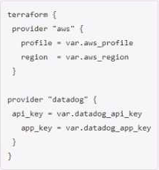
B)
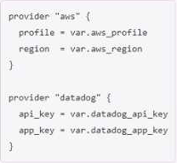
C)
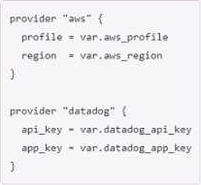
D)
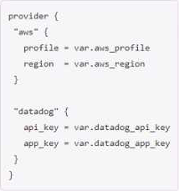
Option A
Option B
Option C
Option D
3. terraform validate confirms that your infrastructure matches the Terraform state file.
True
False
4. Which command must you first run before performing further Terraform operations in a working directory?
terraform import
terraform workspace
terraform plan
terraform init
5. A developer accidentally launched a VM (virtual machine) outside of the Terraform workflow and ended up with two servers with the same name. They don't know which VM Terraform manages but do have a list of all active VM IDs.
Which of the following methods could you use to discover which instance Terraform manages?
Run terraform state list to find the names of all VMs, then run terraform state show for each of them to find which VM ID Terraform manages
Update the code to include outputs for the ID of all VMs, then run terraform plan to view the outputs
Run terraform taint/code on all the VMs to recreate them
Use terraform refresh/code to find out which IDs are already part of state
6. When does Sentinel enforce policy logic during a Terraform Cloud run?
Before the plan phase
During the plan phase
Before the apply phase
After the apply phase
7. You have provisioned some virtual machines (VMs) on Google Cloud Platform (GCP) using the gcloud command line tool. However, you are standardizing with Terraform and want to manage these VMs using Terraform instead.
What are the two things you must do to achieve this? Choose two correct answers.
Run the terraform Import-gcp command
Write Terraform configuration for the existing VMs
Use the terraform import command for the existing VMs
Provision new VMs using Terraform with the same VM names
8. Which of the following ate advantages of using infrastructure as code (laC) instead of provisioning with a graphical user interface (GUI)? Choose two correct answers.
Lets you version, reuse, and share infrastructure configuration
Provisions the same resources at a lower cost
Secures your credentials
Reduces risk of operator error
Prevents manual modifications to your resources
9. Outside of the required_providers block, Terraform configurations always refer to providers by their local names.
True
False
10. Terraform providers are always installed from the Internet.
True
False
11. What feature stops multiple users from operating on the Terraform state at the same time?
State locking
Version control
Provider constraints
Remote backends
12. Which of the following is not a valid siring function in Terraform?
choaf
join
Split
slice
13. What does the default "local" Terraform backend store?
tfplan files
State file
Provider plugins
Terraform binary
14. How can you trigger a run in a Terraform Cloud workspace that is connected to a Version Control System (VCS) repository?
Only Terraform Cloud organization owners can set workspace variables on VCS connected workspaces
Commit a change to the VCS working directory and branch that the Terraform Cloud workspace is connected to
Only Terraform Cloud organization owners can approve plans in VCS connected workspaces
Only members of a VCS organization can open a pull request against repositories that are connected to Terraform Cloud workspaces
15. You're building a CI/CD (continuous integration/continuous delivery) pipeline and need to inject sensitive variables into your Terraform run.
How can you do this safely?
Copy the sensitive variables into your Terraform code
Store the sensitive variables in a secure_var
tf file
Store the sensitive variables as plain text in a source code repository
Pass variables to Terraform with a -var flag
16. When should you write Terraform configuration files for existing infrastructure that you want to start managing with Terraform?
You can import infrastructure without corresponding Terraform code
Terraform will generate the corresponding configuration files for you
Before you run terraform Import
After you run terraform import
17. Variables declared within a module are accessible outside of the module.
True
False
18. Your security team scanned some Terraform workspaces and found secrets stored in plaintext in state files.
How can you protect that data?
Edit your state file to scrub out the sensitive data
Always store your secrets in a secrets.tfvars file
Delete the state file every time you run Terraform
Store the state in an encrypted backend
19. If you update the version constraint in your Terraform configuration, Terraform will update your lock file the next time you run terraform Init.
True
False
20. Once you configure a new Terraform backend with a terraform code block, which command(s) should you use to migrate the state file?
terraform destroy, then terraform apply
terraform init
terraform push
terraform apply
21. What does Terraform use the .terraform.lock.hc1 file for?
There is no such file
Tracking specific provider dependencies
Preventing Terraform runs from occurring
Storing references to workspaces which are locked
22. Why does this backend configuration not follow best practices?
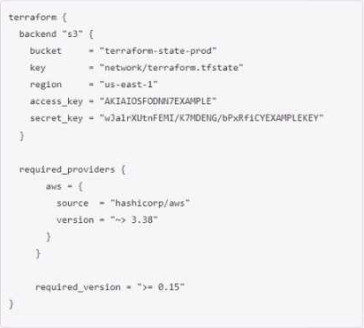
An alias meta-argument should be included in backend blocks whenever possible
You should use the local enhanced storage backend whenever possible
You should not store credentials in Terraform configuration
The backend configuration should contain multiple credentials so that more than one user can execute terraform plan and terraform apply
23. Module variable assignments are inherited from the parent module and you do not need to explicitly set them.
True
False
24. What are some benefits of using Sentinel with Terraform Cloud/Terra form Cloud? Choose three correct answers.
You can enforce a list of approved AWS AMIs
Policy-as-code can enforce security best practices
You can check out and check in cloud access keys
You can restrict specific resource configurations, such as disallowing the use of CIDR=0.0.0.0/0.
Sentinel Policies can be written in HashiCorp Configuration Language (HCL)
25. What does Terraform not reference when running a terraform apply -refresh-only?
State file
Credentials
Cloud provider
Terraform resource definitions in configuration files
26. Which of the following is not a valid Terraform variable type?
list
array
nap
string
27. You decide to move a Terraform state file to Amazon S3 from another location. You write the code below into a file called backend.tf.
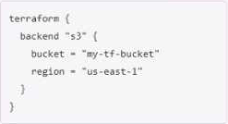
Which command will migrate your current state file to the new S3 remote backend?
terraform state
terraform init
terraform push
terraform refresh
28. Your DevOps team is currently using the local backend for your Terraform configuration. You would like to move to a remote backend to store the state file in a central location.
Which of the following backends would not work?
Artifactory
Amazon S3
Terraform Cloud
Git
29. You have deployed a new webapp with a public IP address on a cloud provider. However, you did not create any outputs for your code.
What is the best method to quickly find the IP address of the resource you deployed?
In a new folder, use the terraform_remote_state data source to load in the state file, then write an output for each resource that you find the state file
Run terraform state list to find the name of the resource, then terraform state show to find the attributes including public IP address
Run terraform output ip_address to view the result
Run terraform destroy then terraform apply and look for the IP address in stdout
30. As a developer, you want to ensure your plugins are up to date with the latest versions.
Which Terraform command should you use?
terraform refresh -upgrade
terraform apply -upgrade
terraform init -upgrade
terraform providers -upgrade
31. What information does the public Terraform Module Registry automatically expose about published modules?
Required input variables
Optional inputs variables and default values
Outputs
All of the above
None of the above
32. You must use different Terraform commands depending on the cloud provider you use.
True
False
33. As a member of an operations team that uses infrastructure as code (lac) practices, you are tasked with making a change to an infrastructure stack running in a public cloud.
Which pattern would follow laC best practices for making a change?
Make the change via the public cloud API endpoint
Clone the repository containing your infrastructure code and then run the code
Use the public cloud console to make the change after a database record has been approved
Make the change programmatically via the public cloud CLI
Submit a pull request and wait for an approved merge of the proposed changes
34. You ate making changes to existing Terraform code to add some new infrastructure. When is the best time to run terraform validate?
After you run terraform apply so you can validate your infrastructure
Before you run terraform apply so you can validate your provider credentials
Before you run terraform plan so you can validate your code syntax
After you run terraform plan so you can validate that your state file is consistent with your infrastructure
35. How would you reference the volume IDs associated with the ebs_block_device blocks in this configuration?
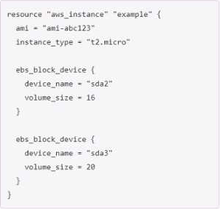
aws_instance.example.ebs_block_device[sda2,sda3).volume_id
aws_lnstance.example.ebs_block_device.[*].volume_id
aws_lnstance.example.ebs_block_device.volume_ids
aws_instance.example-ebs_block_device.*.volume_id
36. Which command should you run to check if all code in a Terraform configuration that references multiple modules is properly formatted without making changes?
terraform fmt -write-false
terraform fmt -list -recursive
terraform fmt -check -recursive
terraform fmt -check
37. What kind of configuration block will create an infrastructure object with settings specified within the block?
provider
state
data
resource
38. What is the Terraform style convention for indenting a nesting level compared to the one above it?
With a tab
With two spaces
With four spaces
With three spaces
39. You have never used Terraform before and would like to test it out using a shared team account for a cloud provider. The shared team account already contains 15 virtual machines (VM). You develop a Terraform configuration containing one VM. perform terraform apply, and see that your VM was created successfully.
What should you do to delete the newly-created VM with Terraform?
The Terraform state file contains all 16 VMs in the team account. Execute terraform destroy and select the newly-created V
Delete the Terraform state file and execute terraform apply.
The Terraform state file only contains the one new V
Execute terraform destroy.
Delete the VM using the cloud provider console and terraform apply to apply the changes to the Terraform state file.
40. When do changes invoked by terraform apply take effect?
After Terraform has updated the state file
Once the resource provider has fulfilled the request
Immediately
None of the above are correct
41. What is the workflow for deploying new infrastructure with Terraform?
Write Terraform configuration, run terraform init to initialize the working directory orworkspace, and run terraform apply
Write Terraform configuration, run terraform show to view proposed changes, and terraform apply to create new infrastructure
Write Terraform configuration, run terraform apply to create infrastructure, use terraform validate to confirm Terraform deployed resources correctly
Write Terraform configuration, run terraform plan to initialize the working directory or workspace, and terraform apply to create the infrastructure
42. You can develop a custom provider to manage its resources using Terraform.
True
False
43. What is one disadvantage of using dynamic blocks in Terraform?
Dynamic blocks can construct repeatable nested blocks
Terraform will run more slowly
They cannot be used to loop through a list of values
They make configuration harder to read and understand
44. Which backend does the Terraform CU use by default?
Depends on the cloud provider configured
HTTP
Remote
Terraform Cloud
Local
45. How does Terraform manage most dependencies between resources?
Terraform will automatically manage most resource dependencies
Using the depends_on parameter
By defining dependencies as modules and including them in a particular order
The order that resources appear in Terraform configuration indicates dependencies
46. You have declared a variable called var.list which is a list of objects that all have an attribute id.
Which options will produce a list of the IDs? Choose two correct answers.
[ var.list [ * ] , id ]
[ for o in var.list: o.Id ]
var.list[*].id
{ for o in var.llst: o => o.id }
47. It is best practice to store secret data in the same version control repository as your Terraform configuration.
True
False
48. _______backends support state locking.
All
No
Some
Only local
49. You want to define a single input variable to capture configuration values for a server. The values must represent memory as a number, and the server name as a string.
Which variable type could you use for this input?
List
Object
Map
Terraform does not support complex input variables of different types
50. Which of the following statements about Terraform modules is not true?
Modules can call other modules
A module is a container for one or more resources
Modules must be publicly accessible
You can call the same module multiple times
51. When you use a remote backend that needs authentication, HashiCorp recommends that you:
Write the authentication credentials in the Terraform configuration files
Keep the Terraform configuration files in a secret store
Push your Terraform configuration to an encrypted git repository
Use partial configuration to load the authentication credentials outside of the Terraform code
52. You can reference a resource created with for_each using a Splat ( *) expression.
True
False
53. Only the user that generated a plan may apply it.
True
False
54. You cannot install third party plugins using terraform init.
True
False
55. Which of these ate features of Terraform Cloud? Choose two correct answers.
Automated infrastructure deployment visualization
Automatic backups
A web-based user interface (Ul)
Remote state storage
56. Setting the TF_LOG environment variable to DEBUG causes debug messages to be logged into stdout.
True
False
57. How does the Terraform cloud integration differ from other state backends such as S3, Consul,etc?
It can execute Terraform runs on dedicated infrastructure in Terraform Cloud
It doesn't show the output of a terraform apply locally
It is only arable lo paying customers
All of the above
58. Which command add existing resources into Terraform state?
Terraform init
Terraform plan
Terraform refresh
Terraform import
All of these
59. In a Terraform Cloud workpace linked to a version control repository speculative plan rum start automatically commit changes to version control.
True
False
60. A Terraform provider is NOT responsible for:
Exposing resources and data sources based on an APUI
Managing actions to take based on resources differences
Understanding API interactions with some service
Provisioning infrastructure in multiple
61. When using multiple configuration of the same Terraform provider, what meta-argument must you include in any non-default provider configurations?
Alias
Id
Depends_on
name
62. Terraform variable names are saved in the state file.
True
False
63. You have created a main.tf Terraform configuration consisting of an application server, a database and a load balanced. You ran terraform apply and Terraform created all of the resources successfully. Now you realize that you do not actually need the load balancer, so you run terraform destroy without any flags.
What will happen?
Terraform will prompt you to pick which resource you want to destroy
Terraform will destroy the application server because it is listed first in the code
Terraform will prompt you to confirm that you want to destroy all the infrastructure
Terraform will destroy the main, tf file
Terraform will immediately destroy all the infrastructure
64. How can a ticket-based system slow down infrastructure provisioning and limit the ability to scale? Choose two correct answers.
End-users have to request infrastructure changes
Ticket based systems generate a full audit trail of the request and fulfillment process
Users can access catalog of approved resources from drop down list in a request form
The more resources your organization needs, the more tickets your infrastructure team has to process
65. You have a Terraform configuration that defines a single virtual machine with no references to it, You have run terraform apply to create the resource, and then removed the resource definition from your Terraform configuration file.
What will happen you run terraform apply in the working directory again?
Terraform will remove the virtual machine from the state file, but the resource will still exist
Nothing
Terraform will error
Terraform will destroy the virtual machine
66. You modified your Terraform configuration and run Terraform plan to review the changes. Simultaneously, your teammate manually modified the infrastructure component you are working on. Since you already ran terraform plan locally, the execution plan for terraform apply will be the same.
True
False
67. Which parameters does terraform import require? Choose two correct answers.
Provider
Resource ID
Resource address
Path
68. What does state looking accomplish?
Prevent accidental Prevent accident deletion of the state file
Blocks Terraform commands from modifying, the state file
Copies the state file from memory to disk
Encrypts any credentials stored within the state file
69. What does this code do?
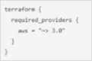
Requires any version of the AWS provider > = 3.0 and <4.0
Requires any version of the AWS provider >= 3.0
Requires any version of the AWS provider > = 3.0 major release. like 4.1
Requires any version of the AWS provider > 3.0
70. Running terraform fmt without any flags in a directory with Terraform configuration files check the formatting of those files without changing their contents.
True
False
71. The public Terraform Module Registry is free to use.
True
False
72. How do you specify a module’s version when publishing it to the public terraform Module Registry?
Configuration it in the module's Terraform code
Mention it on the module's configuration page on the Terraform Module Registry
The Terraform Module Registry does not support versioning modules
Tag a release in the associated repo
73. Provides a browsable directory
Subfolder within a workspace
Generic git repository
Terraform Cloud private registry
Public Terraform module registry
74. Which are examples of infrastructure as code? Choose two correct answers.
Cloned virtual machine images
Versioned configuration files
Change management database records
Doctor files
75. Which of the following command would be use to access all of the attributes and details of a resource managed by Terraform?
Terraform state show ‘ provider_type_name
Terraform state list
Terraform get provider_type_name
Terraform state list provider_type_name

Part 1(Terraform Associate 002)
What of the following approaches needs to be followed in order to select image-4589?
var.images["us-west-1"]
var.images[3]
var.images[2]
lookup(var.images["us-west-1"]
2. By default, a defined provisioner is a creation-time provisioner.
True
False
3. What is the default backend for Terraform?
consul
gcs
local
etcd
4. You want terraform plan and apply to be executed in Terraform Cloud's run environment but the output is to be streamed locally .
Which one of the below you will choose?
Local Backends
This can be done using any of the local or remote backends
Remote Backends
Terraform Backends
5. Which of the following Terraform files should be ignored by Git when committing code to a repo? (select Three)
Files named exactly terraform.tfvars or terraform.tfvars.json.
Any files with names ending in .auto.tfvars or .auto.tfvars.json.
input.tf
terraform.tfstate
output.tf
6. What is the command you can use to set an environment variable named "var1"of type String?
export TF_VAR_VAR1
set TF_VAR_var1
variable "var1" { type = "string"}
export TF_VAR_var1
7. Terraform works well in Windows but a Windows server is required.
False
True
8. You have created 2 workspaces PROD and RQ
You have switched to RQA and provisioned RQA infrastructure from this workspace. Where is your state file stored?
terraform.tfstate.d
terraform.d
terraform.tfstate.RQA
terraform.tfstate
9. Refer to the below code where developer is outputting the value of the database password but has used sensitive parameter to hide the output value in the CLI. output "db_password" { value = aws_db_instance.db.password description = "The password for logging in to the database." sensitive = true}
Since sensitive is set to true, the value associated with db password will not be present in state file as plain-text?
False
True

Part 2(Terraform Associate 002)
1. Which option can not be used to keep secrets out of Terraform configuration files?
A Terraform provider
Environment variables
A -var flag
secure string

2. Terraform can run on Windows or Linux, but it requires a Server version of the Windows operating system.
True
False
3. You have used Terraform to create an ephemeral development environment in the cloud and are now ready to destroy all the infrastructure described by your Terraform configuration. To be safe, you would like to first see all the infrastructure that will be deleted by Terraform.
Which command should you use to show all of the resources that will be deleted? (Choose two.)
Run terraform plan -destroy.
This is not possible. You can only show resources that will be created.
Run terraform state rm *.
Run terraform destroy and it will first output all the resources that will be deleted before prompting for approval.
4. A Terraform provisioner must be nested inside a resource configuration block.
True
False
5. If you manually destroy infrastructure, what is the best practice reflecting this change in Terraform?
Run terraform refresh
It will happen automatically
Manually update the state fire
Run terraform import
6. What is the name assigned by Terraform to reference this resource?
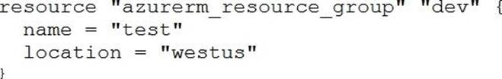
dev
azurerm_resource_group
azurerm
test
7. What command does Terraform require the first time you run it within a configuration directory?
terraform import
terraform init
terraform plan
terraform workspace
8. Only the user that generated a plan may apply it.
True
False
9. You run a local-exec provisioner in a null resource called null_resource.run_script and realize that you need to rerun the script.
Which of the following commands would you use first?
terraform taint null_resource.run_script
terraform apply -target=null_resource.run_script
terraform validate null_resource.run_script
terraform plan -target=null_resource.run_script
10. Where does the Terraform local backend store its state?
In the /tmp directory
In the terraform.tfvars file
In the terraform.tfstate file
In the user's .terraformrc file
11. Which of the following is not a key principle of infrastructure as code?
Versioned infrastructure
Golden images
Idempotence
Self-describing infrastructure
12. Where in your Terraform configuration do you specify a state backend?
The terraform block
The resource block
The provider block
The datasource block
13. You have declared a variable called var.list which is a list of objects that all have an attribute id.
Which options will produce a list of the IDs? (Choose two.)
{ for o in var.list : o => o.id }
var.list[*].id
[ var.list[*].id ]
[ for o in var.list : o.id ]
14. When using a module block to reference a module stored on the public Terraform Module Registry such as:
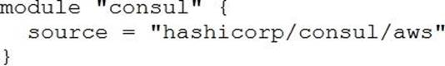
How do you specify version 1.0.0?
Modules stored on the public Terraform Module Registry do not support versioning
Append ?ref=v1.0.0 argument to the source path
Add version = "1.0.0" attribute to module block
Nothing C modules stored on the public Terraform Module Registry always default to version 1.0.0
15. When does terraform apply reflect changes in the cloud environment?
Immediately
However long it takes the resource provider to fulfill the request
After updating the state file
Based on the value provided to the -refresh command line argument
None of the above
16. Which provisioner invokes a process on the resource created by Terraform?
remote-exec
null-exec
local-exec
file
17. What does the default "local" Terraform backend store?
tfplan files
Terraform binary
Provider plugins
State file
18. You have never used Terraform before and would like to test it out using a shared team account for a cloud provider. The shared team account already contains 15 virtual machines (VM). You develop a Terraform configuration containing one VM, perform terraform apply, and see that your VM was created successfully.
What should you do to delete the newly-created VM with Terraform?
The Terraform state file contains all 16 VMs in the team account. Execute terraform destroy and select the newly-created V
The Terraform state file only contains the one new V
Execute terraform destroy.
Delete the Terraform state file and execute Terraform apply.
Delete the VM using the cloud provider console and terraform apply to apply the changes to the Terraform state file.
19. A provider configuration block is required in every Terraform configuration.
Example:
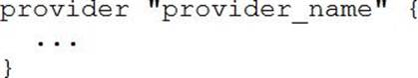
True
False
20. What is not processed when running a terraform refresh?
State file
Configuration file
Credentials
Cloud provider
21. Setting the TF_LOG environment variable to DEBUG causes debug messages to be logged into syslog.
True
False
22. Examine the following Terraform configuration, which uses the data source for an AWS AMI.
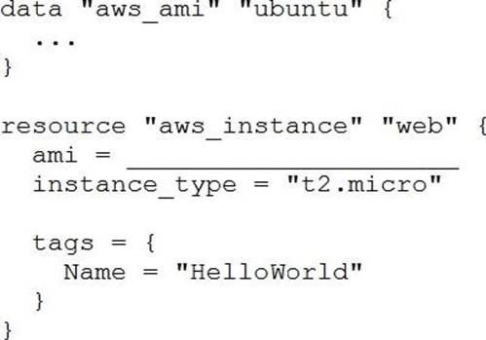
What value should you enter for the ami argument in the AWS instance resource?
aws_ami.ubuntu
data.aws_ami.ubuntu
data.aws_ami.ubuntu.id
aws_ami.ubuntu.id
23. When should you use the force-unlock command?
You see a status message that you cannot acquire the lock
You have a high priority change
Automatic unlocking failed
Your apply failed due to a state lock
24. What information does the public Terraform Module Registry automatically expose about published modules?
Required input variables
Optional inputs variables and default values
Outputs
All of the above
None of the above
25. What is the provider for this fictitious resource?
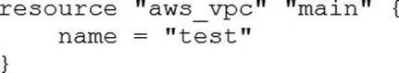
vpc
main
aws
test
26. What is the workflow for deploying new infrastructure with Terraform?
terraform plan to import the current infrastructure to the state file, make code changes, and terraform apply to update the infrastructure
Write a Terraform configuration, run terraform show to view proposed changes, and terraform apply to create new infrastructure.
terraform plan to import the current infrastructure to the state file, make code changes, and terraform apply to update the infrastructure
Write a Terraform configuration, run terraform init, run terraform plan to view planned infrastructure changes, and terraform apply to create new infrastructure.
27. How is the Terraform remote backend different than other state backends such as S3, Consul, etc.?
It can execute Terraform runs on dedicated infrastructure on premises or in Terraform Cloud
It doesn't show the output of a terraform apply locally
It is only available to paying customers
All of the above
28. Which task does terraform init not perform?
Sources all providers present in the configuration and ensures they are downloaded and available locally
Connects to the backend
Sources any modules and copies the configuration locally
Validates all required variables are present
29. Which two steps are required to provision new infrastructure in the Terraform workflow? (Choose two.)
Destroy
Apply
Import
Init
Validate
30. Which of the following is available only in Terraform Enterprise or Cloud workspaces and not in Terraform CLI?
Secure variable storage
Support for multiple cloud providers
Dry runs with terraform plan
Using the workspace as a data source
31. Which of the following is not true of Terraform providers?
Providers can be written by individuals
Providers can be maintained by a community of users
Some providers are maintained by HashiCorp
Major cloud vendors and non-cloud vendors can write, maintain, or collaborate on Terraform providers
None of the above
32. Terraform variables and outputs that set the "description" argument will store that description in the state file.
True
False
33. What features does the hosted service Terraform Cloud provide? (Choose two.)
Automated infrastructure deployment visualization
Automatic backups
Remote state storage
A web-based user interface (UI)
34. Terraform providers are always installed from the Internet.
True
False
35. You should store secret data in the same version control repository as your Terraform configuration.
True
False
36. You have multiple team members collaborating on infrastructure as code (IaC) using Terraform, and want to apply formatting standards for readability.
How can you format Terraform HCL (HashiCorp Configuration Language) code according to standard Terraform style convention?
Run the terraform fmt command during the code linting phase of your CI/CD process
Designate one person in each team to review and format everyone's code
Manually apply two spaces indentation and align equal sign "=" characters in every Terraform file (*.tf)
Write a shell script to transform Terraform files using tools such as AWK, Python, and sed
37. In Terraform 0.13 and above, outside of the required_providers block, Terraform configurations always refer to providers by their local names.
True
False
38. The terraform.tfstate file always matches your currently built infrastructure.
True
False
39. If a module uses a local variable, you can expose that value with a terraform output.
True
False
40. What value does the Terraform Cloud/Terraform Enterprise private module registry provide over the public Terraform Module Registry?
The ability to share modules with public Terraform users and members of Terraform Enterprise Organizations
The ability to tag modules by version or release
The ability to restrict modules to members of Terraform Cloud or Enterprise organizations
The ability to share modules publicly with any user of Terraform
41. Terraform requires the Go runtime as a prerequisite for installation.
True
False
42. One remote backend configuration always maps to a single remote workspace.
True
False
43. terraform init initializes a sample main.tf file in the current directory.
True
False
44. CORRECT TEXT
FILL BLANK
You need to specify a dependency manually.
What resource meta-parameter can you use to make sure Terraform respects the dependency?
Type your answer in the field provided. The text field is not case-sensitive and all variations of the correct answer are accepted.
45. You have recently started a new job at a retailer as an engineer. As part of this new role, you have been tasked with evaluating multiple outages that occurred during peak shopping time during the holiday season. Your investigation found that the team is manually deploying new compute instances and configuring each compute instance manually. This has led to inconsistent configuration between each compute instance.
How would you solve this using infrastructure as code?
Implement a ticketing workflow that makes engineers submit a ticket before manually provisioning and configuring a resource
Implement a checklist that engineers can follow when configuring compute instances
Replace the compute instance type with a larger version to reduce the number of required deployments
Implement a provisioning pipeline that deploys infrastructure configurations committed to your version control system following code reviews
46. Which of the following is not a valid string function in Terraform?
split
join
slice
chomp
47. How would you reference the "name" value of the second instance of this fictitious resource?
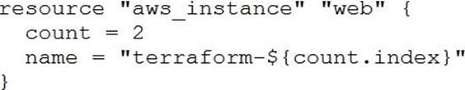
element(aws_instance.web, 2)
aws_instance.web[1].name
aws_instance.web[1]
aws_instance.web[2].name
aws_instance.web.*.name
48. Which of these is the best practice to protect sensitive values in state files?
Blockchain
Secure Sockets Layer (SSL)
Enhanced remote backends
Signed Terraform providers
49. Which of the following is the correct way to pass the value in the variable num_servers into a module with the input servers?
servers = num_servers
servers = variable.num_servers
servers = var(num_servers)
servers = var.num_servers
50. You have provisioned some virtual machines (VMs) on Google Cloud Platform (GCP) using the gcloud command line tool. However, you are standardizing with Terraform and want to manage these VMs using Terraform instead.
What are the two things you must do to achieve this? (Choose two.)
Provision new VMs using Terraform with the same VM names
Use the terraform import command for the existing VMs
Write Terraform configuration for the existing VMs
Run the terraform import-gcp command
51. Why would you use the terraform taint command?
When you want to force Terraform to destroy a resource on the next apply
When you want to force Terraform to destroy and recreate a resource on the next apply
When you want Terraform to ignore a resource on the next apply
When you want Terraform to destroy all the infrastructure in your workspace
52. Which argument(s) is (are) required when declaring a Terraform variable?
type
default
description
All of the above
None of the above
53. What is one disadvantage of using dynamic blocks in Terraform?
They cannot be used to loop through a list of values
Dynamic blocks can construct repeatable nested blocks
They make configuration harder to read and understand
Terraform will run more slowly
54. What command should you run to display all workspaces for the current configuration?
terraform workspace
terraform workspace show
terraform workspace list
terraform show workspace
55. You have deployed a new webapp with a public IP address on a clod provider. However, you did not create any outputs for your code.
What is the best method to quickly find the IP address of the resource you deployed?
Run terraform output ip_address to view the result
In a new folder, use the terraform_remote_state data source to load in the state file, then write an output for each resource that you find the state file
Run terraform state list to find the name of the resource, then terraform state show to find the attributes including public IP address
Run terraform destroy then terraform apply and look for the IP address in stdout
56. terraform validate validates the syntax of Terraform files.
True
False
57. How does Terraform handle working with so many providers?
Terraform ships with all of the plugins embedded in the Terraform binary.
Terraform uses a plugin architecture for providers and only installs the provider plugins required by your configuration in the configuration's working directory.
Terraform uses a plugin architecture for providers and only installs the provider plugins required by your configuration in a shared, system-wide plugins directory.
Terraform allows you to select the providers you want to support during the Terraform installation process.
58. How can you ensure that the engineering team who has access to git repo will not create any non-compliant resources that might lead to a security audit failure in future. your team is using Hashicorp Terraform Enterprise Edition.
Use Terraform OSS Sentinel Lite version, which will save cost, since there is no charge for OSS, but it can still check for most non-compliant rules using Policy-As-Code.
Implement a review process where every code will be reviewed before merging to the master branch.
Since your team is using Hashicorp Terraform Enterprise Edition, enable Sentinel, and write Policy-As-Code rules that will check for non-compliant resource provisioning, and prevent/report them.
Create a design /security document (in PDF) and share to the team, and ask them to always follow that document, and never deviate from it.
59. Terraform has detailed logs which can be enabled by setting the _________ environmental
variable.
TF_TRACE
TF_DEBUG
TF_LOG
TF_INFO
60. True or False: A list(...) contain a number of values of the same type while an object(...) can contain a number of values of different types.
False
True
61. Which of the following best describes the default local backend?
The local backend is where Terraform Enterprise stores logs to be processed by an log collector.
The local backend stores state on the local filesystem, locks the state using system APIs, and performs operations locally.
The local backend is the directory where resources deployed by Terraform have direct access to in order to update their current state.
The local backend is how Terraform connects to public cloud services, such as AWS, Azure, or GC
62. Workspaces in Terraform provides similar functionality in the open-source, Terraform Cloud, and Enterprise versions of Terraform.
True
False
63. You want to get involved in the development of Terraform. As this is an open source project, you would like to contribute a fix for an open issue of Terraform .
What programming language will need to use to write the fix?
It depends on which command issue related to.
Python
Go
Java
64. terraform state subcommands such as list are read-only commands, do read-only commands create state backup files?
Yes
No
65. What is the purpose of using the local-exec provisioner? (Select Two)
To invoke a local executable.
Executes a command on the resource to invoke an update to the Terraform state.
To execute one or more commands on the machine running Terraform.
Ensures that the resource is only executed in the local infrastructure where Terraform is deployed.
66. Refer to the below code where developer is outputting the value of the database password but has used sensitive parameter to hide the output value in the CLI.
output "db_password" { value = aws_db_instance.db.password description = "The password for logging in to the database." sensitive = true}
Since sensitive is set to true, the value associated with db password will not be present in state file as plain-text?
False
True
67. Matt wants to import a manually created EC2 instance into terraform so that he can manage the EC2 instance through terraform going forward. He has written the configuration file of the EC2 instance before importing it to Terraform.
Following is the code:
resource "aws_instance" "matt_ec2" { ami = "ami-bg2640de" instance_type = "t2.micro" vpc_security_group_ids = ["sg-6ae7d613", "sg-53370035"] key_name = "mysecret" subnet_id = "subnet-9e3cfbc5" }
The instance id of that EC2 instance is i-0260835eb7e9bd40 How he can import data of EC2 to state file?
terraform import aws_instance.id = i-0260835eb7e9bd40
terraform import i-0260835eb7e9bd40
terraform import aws_instance.i-0260835eb7e9bd40
terraform import aws_instance.matt_ec2 i-0260835eb7e9bd40
68. Which of the following best describes a Terraform provider?
A plugin that Terraform uses to translate the API interactions with the service or provider.
Serves as a parameter for a Terraform module that allows a module to be customized.
Describes an infrastructure object, such as a virtual network, compute instance, or other components.
A container for multiple resources that are used together.
69. Which of the following type of variable allows multiple values of several distinct types to be grouped together as a single value?
Map
Object
Tuple
List
70. Which of the below terraform commands do not run terraform refresh implicitly before taking actual action of the command?
terraform apply
terraform destroy
terraform init
terraform import
terraform plan
71. When TF_LOG_PATH is set, TF_LOG must be set in order for any logging to be enabled.
False
True
72. John wants to use two different regions to deploy two different EC2 instances.
He has specified two provider blocks in his providers.tf file.
provider "aws" { region = "us-east-1" }
provider "aws" { region = "us-west-2" }
When he run terraform plan he encountered an error .
How to fix this?
Use another provider version
Use alias for region = "us-west-2"
Use default keyword with region = "us-east-1"
It can not be fixed
73. Which of the following command can be used to view the specified version constraints for all providers used in the current configuration.
terraform providers
terraform state show
terraform provider
terraform plan
74. Terraform must track metadata such as resource dependencies. Where is this data stored?
workspace
backend
state file
metadata store
75. Which Terraform command will force a marked resource to be destroyed and recreated on the next apply?
terraform fmt
terraform destroy
terraform taint
terraform refresh
76. terraform refresh will update the state file?
True
False
77. In regards to deploying resources in multi-cloud environments, what are some of the benefits of using Terraform rather than a provider's native tooling? (select three)
Terraform can help businesses deploy applications on multiple clouds and on-premises infrastructure.
Terraform is not cloud-agnostic and can be used to deploy resources across a single public cloud.
Terraform simplifies management and orchestration, helping operators build large-scale, multi-cloud infrastructure.
Terraform can manage cross-cloud dependencies.
78. What is the default backend for Terraform?
consul
gcs
local
etcd
79. }
What of the following approaches needs to be followed in order to select image-4589?
var.images["us-west-1"]
var.images[3]
var.images[2]
lookup(var.images["us-west-1"]
80. Which of the following represents a feature of Terraform Cloud that is NOT free to customers?
Roles and Team Management
WorkSpace Management
Private Module Registry
VCS Integration
81. Terraform init can indeed be run only a few times, because, every time terraform init will initialize the project, and download all plugins from the internet repository, regardless of whether they were present or not, and this increases the waiting time
True
False
82. Terraform import command can import resources into modules as well directly into the root of your state.
True
False
83. Environment variables can be used to set variables. The environment variables must be in the format "____"_<variablename>. Select the correct prefix string from the following list.
TF_CLI_ARGS
TF_VAR
TF_VAR_
TF_VAR_ENV
84. ABC Enterprise has recently tied up with multiple small organizations for exchanging database information. Due to this, the firewall rules are increasing and are more than 100 rules. This is leading firewall configuration file that is difficult to manage .
What is the way this type of configuration can be managed easily?
Terraform Backends
Terraform Functions
Dynamic Blocks
Terraform Expression
85. The Terraform language does not support user-defined functions, and so only the functions built in to the language are available for use.
False
True
86. When using remote state, state is only ever held in memory when used by Terraform.
False
True
87. Which one of the following will run echo 0 and echo 1 on a newly created host?
provisioner "local-exec" { command = "echo 0" command = "echo 1" }
provisioner "remote-exec" { inline = [ echo 0, echo 1 ] }
provisioner "remote-exec" { command = "${echo 0}" command = "${echo 1}" }
provisioner "remote-exec" { inline = [ "echo 0", "echo 1" ] }
88. If you enable TF_LOG = DEBUG, the log will be stored in syslog.log file in the currect directory.
False
True
89. What allows you to conveniently switch between multiple instances of a single configuration within its single backend?
Local backends
Providers
Remote backends
Workspaces
90. What is the command you can use to set an environment variable named "var1"of type String?
export TF_VAR_VAR1
set TF_VAR_var1
variable "var1" { type = "string"}
export TF_VAR_var1

Part 3(Terraform Associate 002)
1. You want to know from which paths Terraform is loading providers referenced in your Terraform configuration (*.tf files). You need to enable debug messages to find this out.
Which of the following would achieve this?
Set the environment variable TF_LOG=TRACE
Set verbose logging for each provider in your Terraform configuration
Set the environment variable TF_VAR_log=TRACE
Set the environment variable TF_LOG_PATH
2. One remote backend configuration always maps to a single remote workspace.
True
False
3. What value does the Terraform Cloud/Terraform Enterprise private module registry provide over the public Terraform Module Registry?
The ability to share modules with public Terraform users and members of Terraform Enterprise Organizations
The ability to tag modules by version or release
The ability to restrict modules to members of Terraform Cloud or Enterprise organizations
The ability to share modules publicly with any user of Terraform
4. Which task does terraform init not perform?
Sources all providers present in the configuration and ensures they are downloaded and available locally
Connects to the backend
Sources any modules and copies the configuration locally
Validates all required variables are present
5. You run a local-exec provisioner in a null resource called null_resource.run_script and realize that you need to rerun the script.
Which of the following commands would you use first?
terraform taint null_resource.run_script
terraform apply -target=null_resource.run_script
terraform validate null_resource.run_script
terraform plan -target=null_resource.run_script
6. Module variable assignments are inherited from the parent module and do not need to be explicitly set.
True
False
7. If a module declares a variable with a default, that variable must also be defined within the module.
True
False
8. Where does the Terraform local backend store its state?
In the /tmp directory
In the terraform.tfvars file
In the terraform.tfstate file
In the user's .terraformrc file
9. When should you use the force-unlock command?
You see a status message that you cannot acquire the lock
You have a high priority change
Automatic unlocking failed
Your apply failed due to a state lock
10. Which of these is the best practice to protect sensitive values in state files?
Blockchain
Secure Sockets Layer (SSL)
Enhanced remote backends
Signed Terraform providers
11. Which two steps are required to provision new infrastructure in the Terraform workflow? (Choose two.)
Destroy
Apply
Import
Init
Validate
12. How can you trigger a run in a Terraform Cloud workspace that is connected to a Version Control System (VCS) repository?
Only Terraform Cloud organization owners can set workspace variables on VCS connected workspaces
Commit a change to the VCS working directory and branch that the Terraform Cloud workspace is connected to
Only members of a VCS organization can open a pull request against repositories that are connected to Terraform Cloud workspaces
Only Terraform Cloud organization owners can approve plans in VCS connected workspaces
13. What is not processed when running a terraform refresh?
State file
Configuration file
Credentials
Cloud provider
14. Only the user that generated a plan may apply it.
True
False
15. The terraform.tfstate file always matches your currently built infrastructure.
True
False
16. You have deployed a new webapp with a public IP address on a clod provider. However, you did not create any outputs for your code.
What is the best method to quickly find the IP address of the resource you deployed?
Run terraform output ip_address to view the result
In a new folder, use the terraform_remote_state data source to load in the state file, then write an output for each resource that you find the state file
Run terraform state list to find the name of the resource, then terraform state show to find the attributes including public IP address
Run terraform destroy then terraform apply and look for the IP address in stdout
17. What is terraform refresh intended to detect?
Terraform configuration code changes
Empty state files
State file drift
Corrupt state files
18. Which of the following is available only in Terraform Enterprise or Cloud workspaces and not in Terraform CLI?
Secure variable storage
Support for multiple cloud providers
Dry runs with terraform plan
Using the workspace as a data source
19. What is the name assigned by Terraform to reference this resource?
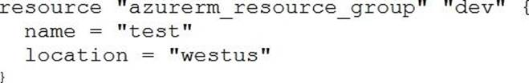
dev
azurerm_resource_group
azurerm
test
20. You have provisioned some virtual machines (VMs) on Google Cloud Platform (GCP) using the gcloud command line tool. However, you are standardizing with Terraform and want to manage these VMs using Terraform instead.
What are the two things you must do to achieve this? (Choose two.)
Provision new VMs using Terraform with the same VM names
Use the terraform import command for the existing VMs
Write Terraform configuration for the existing VMs
Run the terraform import-gcp command
21. In Terraform 0.13 and above, outside of the required_providers block, Terraform configurations always refer to providers by their local names.
True
False
22. terraform validate validates the syntax of Terraform files.
True
False
23. You would like to reuse the same Terraform configuration for your development and production environments with a different state file for each.
Which command would you use?
terraform import
terraform workspace
terraform state
terraform init
24. What information does the public Terraform Module Registry automatically expose about published modules?
Required input variables
Optional inputs variables and default values
Outputs
All of the above
None of the above
25. Which of the following is not a valid string function in Terraform?
split
join
slice
chomp
26. You’re building a CI/CD (continuous integration/ continuous delivery) pipeline and need to inject sensitive variables into your Terraform run.
How can you do this safely?
Pass variables to Terraform with a Cvar flag
Copy the sensitive variables into your Terraform code
Store the sensitive variables in a secure_vars.tf file
Store the sensitive variables as plain text in a source code repository
27. HashiCorp Configuration Language (HCL) supports user-defined functions.
True
False
28. Which of the following is not true of Terraform providers?
Providers can be written by individuals
Providers can be maintained by a community of users
Some providers are maintained by HashiCorp
Major cloud vendors and non-cloud vendors can write, maintain, or collaborate on Terraform providers
None of the above
29. Which argument(s) is (are) required when declaring a Terraform variable?
type
default
description
All of the above
None of the above
30. A provider configuration block is required in every Terraform configuration.
Example:
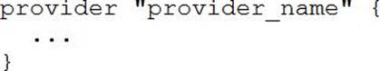
True
False
31. In contrast to Terraform Open Source, when working with Terraform Enterprise and Cloud Workspaces, conceptually you could think about them as completely separate working directories.
True
False
32. Terraform requires the Go runtime as a prerequisite for installation.
True
False
33. What is the name assigned by Terraform to reference this resource?
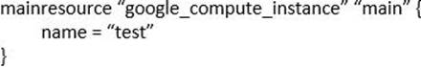
compute_instance
main
google
teat
34. When using Terraform to deploy resources into Azure, which scenarios are true regarding state files? (Choose two.)
When a change is made to the resources via the Azure Cloud Console, the changes are recorded in a new state file
When a change is made to the resources via the Azure Cloud Console, Terraform will update the state file to reflect them during the next plan or apply
When a change is made to the resources via the Azure Cloud Console, the current state file will not be updated
When a change is made to the resources via the Azure Cloud Console, the changes are recorded in the current state file
35. terraform init initializes a sample main.tf file in the current directory.
True
False
36. Where in your Terraform configuration do you specify a state backend?
The terraform block
The resource block
The provider block
The datasource block
37. If you manually destroy infrastructure, what is the best practice reflecting this change in Terraform?
Run terraform refresh
It will happen automatically
Manually update the state fire
Run terraform import
38. How is the Terraform remote backend different than other state backends such as S3, Consul, etc.?
It can execute Terraform runs on dedicated infrastructure on premises or in Terraform Cloud
It doesn't show the output of a terraform apply locally
It is only available to paying customers
All of the above
39. Which option can not be used to keep secrets out of Terraform configuration files?
A Terraform provider
Environment variables
A -var flag
secure string
40. Terraform can import modules from a number of sources C which of the following is not a valid source?
FTP server
GitHub repository
Local path
Terraform Module Registry
41. Terraform variables and outputs that set the "description" argument will store that description in the state file.
True
False
42. What type of block is used to construct a collection of nested configuration blocks?
for_each
repeated
nesting
dynamic
43. Which of the following is not an action performed by terraform init?
Create a sample main.tf file
Initialize a configured backend
Retrieve the source code for all referenced modules
Load required provider plugins
44. If writing Terraform code that adheres to the Terraform style conventions, how would you properly indent each nesting level compared to the one above it?
With four spaces
With a tab
With three spaces
With two spaces
45. What features stops multiple admins from changing the Terraform state at the same time?
Version control
Backend types
Provider constraints
State locking
46. Which backend does the Terraform CLI use by default?
Terraform Cloud
Consul
Remote
Local
47. What features does the hosted service Terraform Cloud provide? (Choose two.)
Automated infrastructure deployment visualization
Automatic backups
Remote state storage
A web-based user interface (UI)
48. Setting the TF_LOG environment variable to DEBUG causes debug messages to be logged into syslog.
True
False
49. A Terraform provisioner must be nested inside a resource configuration block.
True
False
50. When running the command terraform taint against a managed resource you want to force recreation upon, Terraform will immediately destroy and recreate the resource.
True
False
51. You write a new Terraform configuration and immediately run terraform apply in the CLI using the local backend.
Why will the apply fail?
Terraform needs you to format your code according to best practices first
Terraform needs to install the necessary plugins first
The Terraform CLI needs you to log into Terraform cloud first
Terraform requires you to manually run terraform plan first
52. Which of these options is the most secure place to store secrets foe connecting to a Terraform remote backend?
Defined in Environment variables
Inside the backend block within the Terraform configuration
Defined in a connection configuration outside of Terraform
None of above
53. Which of the following is the correct way to pass the value in the variable num_servers into a module with the input servers?
servers = num_servers
servers = variable.num_servers
servers = var(num_servers)
servers = var.num_servers
54. You should store secret data in the same version control repository as your Terraform configuration.
True
False
55. You just scaled your VM infrastructure and realized you set the count variable to the wrong value. You correct the value and save your change.
What do you do next to make your infrastructure match your configuration?
Run an apply and confirm the planned changes
Inspect your Terraform state because you want to change it
Reinitialize because your configuration has changed
Inspect all Terraform outputs to make sure they are correct
56. Terraform provisioners that require authentication can use the ______ block.
connection
credentials
secrets
ssh
57. You have never used Terraform before and would like to test it out using a shared team account for a cloud provider. The shared team account already contains 15 virtual machines (VM). You develop a Terraform configuration containing one VM, perform terraform apply, and see that your VM was created successfully.
What should you do to delete the newly-created VM with Terraform?
The Terraform state file contains all 16 VMs in the team account. Execute terraform destroy and select the newly-created V
The Terraform state file only contains the one new V
Execute terraform destroy.
Delete the Terraform state file and execute Terraform apply.
Delete the VM using the cloud provider console and terraform apply to apply the changes to the Terraform state file.
58. You have multiple team members collaborating on infrastructure as code (IaC) using Terraform, and want to apply formatting standards for readability.
How can you format Terraform HCL (HashiCorp Configuration Language) code according to standard Terraform style convention?
Run the terraform fmt command during the code linting phase of your CI/CD process
Designate one person in each team to review and format everyone's code
Manually apply two spaces indentation and align equal sign "=" characters in every Terraform file (*.tf)
Write a shell script to transform Terraform files using tools such as AWK, Python, and sed
59. A fellow developer on your team is asking for some help in refactoring their Terraform code. As part of their application’s architecture, they are going to tear down an existing deployment managed by Terraform and deploy
new. However, there is a server resource named aws_instance.ubuntu[1] they would like to keep to perform some additional analysis.
What command should be used to tell Terraform to no longer manage the resource?
terraform apply rm aws_instance.ubuntu[1]
terraform state rm aws_instance.ubuntu[1]
terraform plan rm aws_instance.ubuntu[1]
terraform delete aws_instance.ubuntu[1]
60. Which of the following is not a key principle of infrastructure as code?
Versioned infrastructure
Golden images
Idempotence
Self-describing infrastructure
61. You have declared a variable called var.list which is a list of objects that all have an attribute id.
Which options will produce a list of the IDs? (Choose two.)
{ for o in var.list : o => o.id }
var.list[*].id
[ var.list[*].id ]
[ for o in var.list : o.id ]
62. You need to deploy resources into two different cloud regions in the same Terraform configuration.
To do that, you declare multiple provider configurations as follows:
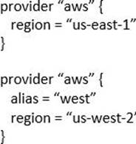
What meta-argument do you need to configure in a resource block to deploy the resource to the “us-west-2” AWS region?
alias = west
provider = west
provider = aws.west
alias = aws.west
63. Terraform can run on Windows or Linux, but it requires a Server version of the Windows operating system.
True
False
64. Terraform provisioners can be added to any resource block.
True
False
65. When you initialize Terraform, where does it cache modules from the public Terraform Module Registry?
On disk in the /tmp directory
In memory
On disk in the .terraform sub-directory
They are not cached
66. You have declared an input variable called environment in your parent module .
What must you do to pass the value to a child module in the configuration?
Add node_count = var.node_count
Declare the variable in a terraform.tfvars file
Declare a node_count input variable for child module
Nothing, child modules inherit variables of parent module
67. You have recently started a new job at a retailer as an engineer. As part of this new role, you have been tasked with evaluating multiple outages that occurred during peak shopping time during the holiday season. Your investigation found that the team is manually deploying new compute instances and configuring each compute instance manually. This has led to inconsistent configuration between each compute instance.
How would you solve this using infrastructure as code?
Implement a ticketing workflow that makes engineers submit a ticket before manually provisioning and configuring a resource
Implement a checklist that engineers can follow when configuring compute instances
Replace the compute instance type with a larger version to reduce the number of required deployments
Implement a provisioning pipeline that deploys infrastructure configurations committed to your version control system following code reviews
68. When using a module block to reference a module stored on the public Terraform Module Registry such as:
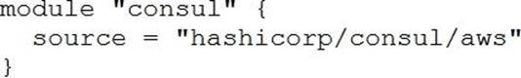
How do you specify version 1.0.0?
Modules stored on the public Terraform Module Registry do not support versioning
Append ?ref=v1.0.0 argument to the source path
Add version = "1.0.0" attribute to module block
Nothing C modules stored on the public Terraform Module Registry always default to version 1.0.0
69. CORRECT TEXT
FILL BLANK
What is the name of the default file where Terraform stores the state?
Type your answer in the field provided. The text field is not case-sensitive and all variations of the correct answer are accepted.
70. You have a simple Terraform configuration containing one virtual machine (VM) in a cloud provider. You run terraform apply and the VM is created successfully.
What will happen if you delete the VM using the cloud provider console, and run terraform apply again without changing any Terraform code?
Terraform will remove the VM from state file
Terraform will report an error
Terraform will not make any changes
Terraform will recreate the VM
71. CORRECT TEXT
FILL BLANK
Which flag would you add to terraform plan to save the execution plan to a file?
Type your answer in the field provided. The text field is not case-sensitive and all variations of the correct answer are accepted.
72. How would you reference the "name" value of the second instance of this fictitious resource?
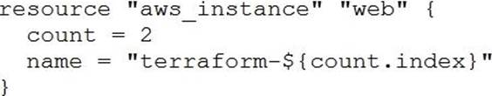
element(aws_instance.web, 2)
aws_instance.web[1].name
aws_instance.web[1]
aws_instance.web[2].name
aws_instance.web.*.name
73. What is the provider for this fictitious resource?
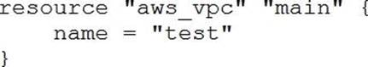
vpc
main
aws
test
74. Which of the following is not a valid Terraform collection type?
list
map
tree
set
75. You have used Terraform to create an ephemeral development environment in the cloud and are now ready to destroy all the infrastructure described by your Terraform configuration. To be safe, you would like to first see all the infrastructure that will be deleted by Terraform.
Which command should you use to show all of the resources that will be deleted? (Choose two.)
Run terraform plan -destroy.
This is not possible. You can only show resources that will be created.
Run terraform state rm *.
Run terraform destroy and it will first output all the resources that will be deleted before prompting for approval.
76. Which statement describes a goal of infrastructure as code?
An abstraction from vendor specific APIs
Write once, run anywhere
A pipeline process to test and deliver software
The programmatic configuration of resources
77. Examine the following Terraform configuration, which uses the data source for an AWS AMI.
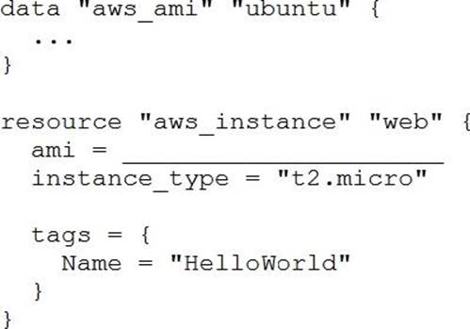
What value should you enter for the ami argument in the AWS instance resource?
aws_ami.ubuntu
data.aws_ami.ubuntu
data.aws_ami.ubuntu.id
aws_ami.ubuntu.id
78. How can terraform plan aid in the development process?
Validates your expectations against the execution plan without permanently modifying state
Initializes your working directory containing your Terraform configuration files
Formats your Terraform configuration files
Reconciles Terraform’s state against deployed resources and permanently modifies state using the current status of deployed resources
79. A Terraform provider is not responsible for:
Understanding API interactions with some service
Provisioning infrastructure in multiple clouds
Exposing resources and data sources based on an API
Managing actions to take based on resource differences
80. Which provisioner invokes a process on the resource created by Terraform?
remote-exec
null-exec
local-exec
file
81. How is terraform import run?
As a part of terraform init
As a part of terraform plan
As a part of terraform refresh
By an explicit call
All of the above
82. Terraform providers are always installed from the Internet.
True
False
83. CORRECT TEXT
FILL BLANK
You need to specify a dependency manually.
What resource meta-parameter can you use to make sure Terraform respects the dependency?
Type your answer in the field provided. The text field is not case-sensitive and all variations of the correct answer are accepted.
84. Which of the following is allowed as a Terraform variable name?
count
name
source
version
85. What is the workflow for deploying new infrastructure with Terraform?
terraform plan to import the current infrastructure to the state file, make code changes, and terraform apply to update the infrastructure
Write a Terraform configuration, run terraform show to view proposed changes, and terraform apply to create new infrastructure.
terraform plan to import the current infrastructure to the state file, make code changes, and terraform apply to update the infrastructure
Write a Terraform configuration, run terraform init, run terraform plan to view planned infrastructure changes, and terraform apply to create new infrastructure.
86. Terraform can only manage resource dependencies if you set them explicitly with the depends_on argument.
True
False
87. When does terraform apply reflect changes in the cloud environment?
Immediately
However long it takes the resource provider to fulfill the request
After updating the state file
Based on the value provided to the -refresh command line argument
None of the above
88. What is one disadvantage of using dynamic blocks in Terraform?
They cannot be used to loop through a list of values
Dynamic blocks can construct repeatable nested blocks
They make configuration harder to read and understand
Terraform will run more slowly
89. What command does Terraform require the first time you run it within a configuration directory?
terraform import
terraform init
terraform plan
terraform workspace
90. Your DevOps team is currently using the local backend for your Terraform configuration. You would like to move to a remote backend to begin storing the state file in a central location.
Which of the following backends would not work?
Amazon S3
Artifactory
Git
Terraform Cloud
91. What does the default "local" Terraform backend store?
tfplan files
Terraform binary
Provider plugins
State file
92. Why would you use the terraform taint command?
When you want to force Terraform to destroy a resource on the next apply
When you want to force Terraform to destroy and recreate a resource on the next apply
When you want Terraform to ignore a resource on the next apply
When you want Terraform to destroy all the infrastructure in your workspace
93. All standard backend types support state storage, locking, and remote operations like plan.
apply and destroy.
True
False
94. A terraform apply can not _________ infrastructure.
change
destroy
provision
import
95. Terraform and Terraform providers must use the same major version number in a single configuration.
True
False
96. Terraform validate reports syntax check errors from which of the following scenarios?
Code contains tabs indentation instead of spaces
There is missing value for a variable
The state files does not match the current infrastructure
None of the above
97. A Terraform local value can reference other Terraform local values.
True
False
98. If a module uses a local variable, you can expose that value with a terraform output.
True
False
99. What command should you run to display all workspaces for the current configuration?
terraform workspace
terraform workspace show
terraform workspace list
terraform show workspace
100. Your security team scanned some Terraform workspaces and found secrets stored in a plaintext in state files.
How can you protect sensitive data stored in Terraform state files?
Delete the state file every time you run Terraform
Store the state in an encrypted backend
Edit your state file to scrub out the sensitive data
Always store your secrets in a secrets.tfvars file.

Part 4(Terraform Associate 002)
1. Terraform can run on Windows or Linux, but it requires a Server version of the Windows operating system.
True
False
2. Which of the following is not a valid Terraform collection type?
list
map
tree
set
3. Why would you use the terraform taint command?
When you want to force Terraform to destroy a resource on the next apply
When you want to force Terraform to destroy and recreate a resource on the next apply
When you want Terraform to ignore a resource on the next apply
When you want Terraform to destroy all the infrastructure in your workspace
4. Which provisioner invokes a process on the resource created by Terraform?
remote-exec
null-exec
local-exec
file
5. Setting the TF_LOG environment variable to DEBUG causes debug messages to be logged into syslog.
True
False
6. When running the command terraform taint against a managed resource you want to force recreation upon, Terraform will immediately destroy and recreate the resource.
True
False
7. How would you reference the "name" value of the second instance of this fictitious resource?
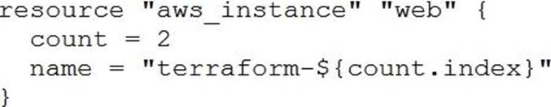
element(aws_instance.web, 2)
aws_instance.web[1].name
aws_instance.web[1]
aws_instance.web[2].name
aws_instance.web.*.name
8. What value does the Terraform Cloud/Terraform Enterprise private module registry provide over the public Terraform Module Registry?
The ability to share modules with public Terraform users and members of Terraform Enterprise Organizations
The ability to tag modules by version or release
The ability to restrict modules to members of Terraform Cloud or Enterprise organizations
The ability to share modules publicly with any user of Terraform
9. Terraform and Terraform providers must use the same major version number in a single configuration.
True
False
10. When using Terraform to deploy resources into Azure, which scenarios are true regarding state files? (Choose two.)
When a change is made to the resources via the Azure Cloud Console, the changes are recorded in a new state file
When a change is made to the resources via the Azure Cloud Console, Terraform will update the state file to reflect them during the next plan or apply
When a change is made to the resources via the Azure Cloud Console, the current state file will not be updated
When a change is made to the resources via the Azure Cloud Console, the changes are recorded in the current state file
11. What information does the public Terraform Module Registry automatically expose about published modules?
Required input variables
Optional inputs variables and default values
Outputs
All of the above
None of the above
12. You have declared an input variable called environment in your parent module.
What must you do to pass the value to a child module in the configuration?
Add node_count = var.node_count
Declare the variable in a terraform.tfvars file
Declare a node_count input variable for child module
Nothing, child modules inherit variables of parent module
13. You have deployed a new webapp with a public IP address on a clod provider. However, you did not create any outputs for your code.
What is the best method to quickly find the IP address of the resource you deployed?
Run terraform output ip_address to view the result
In a new folder, use the terraform_remote_state data source to load in the state file, then write an output for each resource that you find the state file
Run terraform state list to find the name of the resource, then terraform state show to find the attributes including public IP address
Run terraform destroy then terraform apply and look for the IP address in stdout
14. If writing Terraform code that adheres to the Terraform style conventions, how would you properly indent each nesting level compared to the one above it?
With four spaces
With a tab
With three spaces
With two spaces
15. When using a module block to reference a module stored on the public Terraform Module Registry such as:
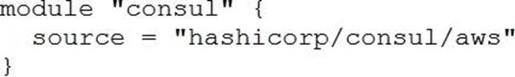
How do you specify version 1.0.0?
Modules stored on the public Terraform Module Registry do not support versioning
Append ?ref=v1.0.0 argument to the source path
Add version = "1.0.0" attribute to module block
Nothing C modules stored on the public Terraform Module Registry always default to version 1.0.0
16. In Terraform 0.13 and above, outside of the required_providers block, Terraform configurations always refer to providers by their local names.
True
False
17. Terraform requires the Go runtime as a prerequisite for installation.
True
False
18. Where does the Terraform local backend store its state?
In the /tmp directory
In the terraform.tfvars file
In the terraform.tfstate file
In the user's .terraformrc file
19. When does terraform apply reflect changes in the cloud environment?
Immediately
However long it takes the resource provider to fulfill the request
After updating the state file
Based on the value provided to the -refresh command line argument
None of the above
20. Which of the following is not true of Terraform providers?
Providers can be written by individuals
Providers can be maintained by a community of users
Some providers are maintained by HashiCorp
Major cloud vendors and non-cloud vendors can write, maintain, or collaborate on Terraform providers
None of the above
21. You have provisioned some virtual machines (VMs) on Google Cloud Platform (GCP) using the gcloud command line tool. However, you are standardizing with Terraform and want to manage these VMs using Terraform instead.
What are the two things you must do to achieve this? (Choose two.)
Provision new VMs using Terraform with the same VM names
Use the terraform import command for the existing VMs
Write Terraform configuration for the existing VMs
Run the terraform import-gcp command
22. All standard backend types support state storage, locking, and remote operations like plan.
apply and destroy.
True
False
23. If you manually destroy infrastructure, what is the best practice reflecting this change in Terraform?
Run terraform refresh
It will happen automatically
Manually update the state fire
Run terraform import
24. You just scaled your VM infrastructure and realized you set the count variable to the wrong value. You correct the value and save your change.
What do you do next to make your infrastructure match your configuration?
Run an apply and confirm the planned changes
Inspect your Terraform state because you want to change it
Reinitialize because your configuration has changed
Inspect all Terraform outputs to make sure they are correct
25. Which backend does the Terraform CLI use by default?
Terraform Cloud
Consul
Remote
Local
26. In contrast to Terraform Open Source, when working with Terraform Enterprise and Cloud Workspaces, conceptually you could think about them as completely separate working directories.
True
False
27. Which of these is the best practice to protect sensitive values in state files?
Blockchain
Secure Sockets Layer (SSL)
Enhanced remote backends
Signed Terraform providers
28. When should you use the force-unlock command?
You see a status message that you cannot acquire the lock
You have a high priority change
Automatic unlocking failed
Your apply failed due to a state lock
29. A Terraform provider is not responsible for:
Understanding API interactions with some service
Provisioning infrastructure in multiple clouds
Exposing resources and data sources based on an API
Managing actions to take based on resource differences
30. Which of the following is allowed as a Terraform variable name?
count
name
source
version
31. The terraform.tfstate file always matches your currently built infrastructure.
True
False
32. You write a new Terraform configuration and immediately run terraform apply in the CLI using the local backend.
Why will the apply fail?
Terraform needs you to format your code according to best practices first
Terraform needs to install the necessary plugins first
The Terraform CLI needs you to log into Terraform cloud first
Terraform requires you to manually run terraform plan first
33. You should store secret data in the same version control repository as your Terraform configuration.
True
False
34. How is terraform import run?
As a part of terraform init
As a part of terraform plan
As a part of terraform refresh
By an explicit call
All of the above
35. Terraform validate reports syntax check errors from which of the following scenarios?
Code contains tabs indentation instead of spaces
There is missing value for a variable
The state files does not match the current infrastructure
None of the above
36. Terraform can only manage resource dependencies if you set them explicitly with the depends_on argument.
True
False
37. CORRECT TEXT
FILL BLANK
Which flag would you add to terraform plan to save the execution plan to a file? Type your answer in the field provided. The text field is not case-sensitive and all variations of the correct answer are accepted. terraform plan -out=tfplan
38. You have a simple Terraform configuration containing one virtual machine (VM) in a cloud provider. You run terraform apply and the VM is created successfully.
What will happen if you delete the VM using the cloud provider console, and run terraform apply again without changing any Terraform code?
Terraform will remove the VM from state file
Terraform will report an error
Terraform will not make any changes
Terraform will recreate the VM
39. Which of the following is not a key principle of infrastructure as code?
Versioned infrastructure
Golden images
Idempotence
Self-describing infrastructure
40. You have declared a variable called var.list which is a list of objects that all have an attribute id.
Which options will produce a list of the IDs? (Choose two.)
{ for o in var.list : o => o.id }
var.list[*].id
[ var.list[*].id ]
[ for o in var.list : o.id ]
41. How can you trigger a run in a Terraform Cloud workspace that is connected to a Version Control System (VCS) repository?
Only Terraform Cloud organization owners can set workspace variables on VCS connected workspaces
Commit a change to the VCS working directory and branch that the Terraform Cloud workspace is connected to
Only members of a VCS organization can open a pull request against repositories that are connected to Terraform Cloud workspaces
Only Terraform Cloud organization owners can approve plans in VCS connected workspaces
42. What is not processed when running a terraform refresh?
State file
Configuration file
Credentials
Cloud provider
43. Terraform provisioners can be added to any resource block.
True
False
44. A fellow developer on your team is asking for some help in refactoring their Terraform code. As part of their application’s architecture, they are going to tear down an existing deployment managed by Terraform and deploy new. However, there is a server resource named aws_instance.ubuntu[1] they would like to keep to perform some additional analysis.
What command should be used to tell Terraform to no longer manage the resource?
terraform apply rm aws_instance.ubuntu[1]
terraform state rm aws_instance.ubuntu[1]
terraform plan rm aws_instance.ubuntu[1]
terraform delete aws_instance.ubuntu[1]
45. What is the provider for this fictitious resource?
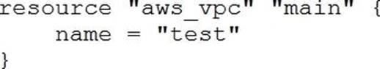
vpc
main
aws
test
46. Which argument(s) is (are) required when declaring a Terraform variable?
type
default
description
All of the above
None of the above
47. You have multiple team members collaborating on infrastructure as code (IaC) using Terraform, and want to apply formatting standards for readability.
How can you format Terraform HCL (HashiCorp Configuration Language) code according to standard Terraform style convention?
Run the terraform fmt command during the code linting phase of your CI/CD process
Designate one person in each team to review and format everyone's code
Manually apply two spaces indentation and align equal sign "=" characters in every Terraform file (*.tf)
Write a shell script to transform Terraform files using tools such as AWK, Python, and sed
48. Which of the following is available only in Terraform Enterprise or Cloud workspaces and not in Terraform CLI?
Secure variable storage
Support for multiple cloud providers
Dry runs with terraform plan
Using the workspace as a data source
49. What is the name assigned by Terraform to reference this resource?
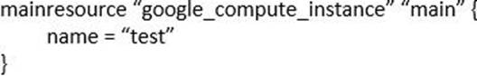
compute_instance
main
google
test
50. You have recently started a new job at a retailer as an engineer. As part of this new role, you have been tasked with evaluating multiple outages that occurred during peak shopping time during the holiday season. Your investigation found that the team is manually deploying new compute instances and configuring each compute instance manually. This has led to inconsistent configuration between each compute instance.
How would you solve this using infrastructure as code?
Implement a ticketing workflow that makes engineers submit a ticket before manually provisioning and configuring a resource
Implement a checklist that engineers can follow when configuring compute instances
Replace the compute instance type with a larger version to reduce the number of required deployments
Implement a provisioning pipeline that deploys infrastructure configurations committed to your version control system following code reviews
51. terraform validate validates the syntax of Terraform files.
True
False
52. How can terraform plan aid in the development process?
Validates your expectations against the execution plan without permanently modifying state
Initializes your working directory containing your Terraform configuration files
Formats your Terraform configuration files
Reconciles Terraform’s state against deployed resources and permanently modifies state using the current status of deployed resources
53. Your security team scanned some Terraform workspaces and found secrets stored in a plaintext in state files.
How can you protect sensitive data stored in Terraform state files?
Delete the state file every time you run Terraform
Store the state in an encrypted backend
Edit your state file to scrub out the sensitive data
Always store your secrets in a secrets.tfvars file.
54. A Terraform local value can reference other Terraform local values.
True
False
55. You want to know from which paths Terraform is loading providers referenced in your Terraform configuration (files). You need to enable debug messages to find this out.
Which of the following would achieve this?
Set the environment variable TF_LOG=TRACE
Set verbose logging for each provider in your Terraform configuration
Set the environment variable TF_VAR_log=TRACE
Set the environment variable TF_LOG_PATH
56. You have never used Terraform before and would like to test it out using a shared team account for a cloud provider. The shared team account already contains 15 virtual machines (VM). You develop a Terraform configuration containing one VM, perform terraform apply, and see that your VM was created successfully.
What should you do to delete the newly-created VM with Terraform?
The Terraform state file contains all 16 VMs in the team account. Execute terraform destroy and select the newly-created V
The Terraform state file only contains the one new V
Execute terraform destroy.
Delete the Terraform state file and execute Terraform apply.
Delete the VM using the cloud provider console and terraform apply to apply the changes to the Terraform state file.
57. You run a local-exec provisioner in a null resource called null_resource.run_script and realize that you need to rerun the script.
Which of the following commands would you use first?
terraform taint null_resource.run_script
terraform apply -target=null_resource.run_script
terraform validate null_resource.run_script
terraform plan -target=null_resource.run_script
58. Terraform providers are always installed from the Internet.
True
False
59. How is the Terraform remote backend different than other state backends such as S3, Consul, etc.?
It can execute Terraform runs on dedicated infrastructure on premises or in Terraform Cloud
It doesn't show the output of a terraform apply locally
It is only available to paying customers
All of the above
60. A terraform apply can not _________ infrastructure.
change
destroy
provision
import
61. You need to constrain the GitHub provider to version 2.1 or greater.
Which of the following should you put into the Terraform 0.12 configuration’s provider block?
version >= 2.1
version ~> 2.1
version = “<= 2.1”
version = “>= 2.1”
62. Which of the following is not a valid string function in Terraform?
split
join
slice
chomp
63. HashiCorp Configuration Language (HCL) supports user-defined functions.
True
False
64. Which option can not be used to keep secrets out of Terraform configuration files?
A Terraform provider
Environment variables
A -var flag
secure string
65. You have used Terraform to create an ephemeral development environment in the cloud and are now ready to destroy all the infrastructure described by your Terraform configuration. To be safe, you would like to first see all the infrastructure that will be deleted by Terraform.
Which command should you use to show all of the resources that will be deleted? (Choose two.)
Run terraform plan -destroy.
This is not possible. You can only show resources that will be created.
Run terraform state rm *.
Run terraform destroy and it will first output all the resources that will be deleted before prompting for approval.
66. What is the name assigned by Terraform to reference this resource?
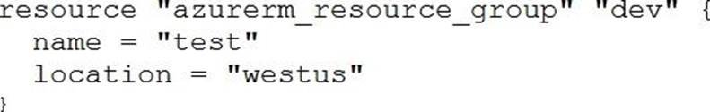
dev
azurerm_resource_group
azurerm
test
67. What type of block is used to construct a collection of nested configuration blocks?
for_each
repeated
nesting
dynamic
68. When you initialize Terraform, where does it cache modules from the public Terraform Module Registry?
On disk in the /tmp directory
In memory
On disk in the .terraform sub-directory
They are not cached
69. What is the workflow for deploying new infrastructure with Terraform?
terraform plan to import the current infrastructure to the state file, make code changes, and terraform apply to update the infrastructure
Write a Terraform configuration, run terraform show to view proposed changes, and terraform apply to create new infrastructure.
terraform plan to import the current infrastructure to the state file, make code changes, and terraform apply to update the infrastructure
Write a Terraform configuration, run terraform init, run terraform plan to view planned infrastructure changes, and terraform apply to create new infrastructure.
70. What command does Terraform require the first time you run it within a configuration directory?
terraform import
terraform init
terraform plan
terraform workspace
71. Which of the following is the correct way to pass the value in the variable num_servers into a module with the input servers?
servers = num_servers
servers = variable.num_servers
servers = var(num_servers)
servers = var.num_servers
72. What does the default "local" Terraform backend store?
tfplan files
Terraform binary
Provider plugins
State file
73. You’re building a CI/CD (continuous integration/ continuous delivery) pipeline and need to inject sensitive variables into your Terraform run.
How can you do this safely?
Pass variables to Terraform with a Cvar flag
Copy the sensitive variables into your Terraform code
Store the sensitive variables in a secure_vars.tf file
Store the sensitive variables as plain text in a source code repository
74. Your DevOps team is currently using the local backend for your Terraform configuration. You would like to move to a remote backend to begin storing the state file in a central location.
Which of the following backends would not work?
Amazon S3
Artifactory
Git
Terraform Cloud
75. Where in your Terraform configuration do you specify a state backend?
The terraform block
The resource block
The provider block
The datasource block
76. You would like to reuse the same Terraform configuration for your development and production environments with a different state file for each.
Which command would you use?
terraform import
terraform workspace
terraform state
terraform init
77. Module variable assignments are inherited from the parent module and do not need to be explicitly set.
True
False
78. One remote backend configuration always maps to a single remote workspace.
True
False
79. CORRECT TEXT
FILL BLANK
What is the name of the default file where Terraform stores the state?
Type your answer in the field provided. The text field is not case-sensitive and all variations of the correct answer are accepted. terraform.tfstate
80. What is one disadvantage of using dynamic blocks in Terraform?
They cannot be used to loop through a list of values
Dynamic blocks can construct repeatable nested blocks
They make configuration harder to read and understand
Terraform will run more slowly

Part 5(Terraform Associate 002)
1. If a module declares a variable with a default, that variable must also be defined within the module.
True
False
2. Your security team scanned some Terraform workspaces and found secrets stored in a plaintext in state files.
How can you protect sensitive data stored in Terraform state files?
Delete the state file every time you run Terraform
Store the state in an encrypted backend
Edit your state file to scrub out the sensitive data
Always store your secrets in a secrets.tfvars file.
3. What does the default "local" Terraform backend store?
tfplan files
Terraform binary
Provider plugins
State file
4. What is the name assigned by Terraform to reference this resource?
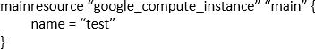
dev
azurerm_resource_group
azurerm
test
5. You have declared an input variable called environment in your parent module.
What must you do to pass the value to a child module in the configuration?
Add node_count = var.node_count
Declare the variable in a terraform.tfvars file
Declare a node_count input variable for child module
Nothing, child modules inherit variables of parent module
6. You have declared a variable called var.list which is a list of objects that all have an attribute id.
Which options will produce a list of the IDs? (Choose two.)
{ for o in var.list: o => o.id }
var.list[*].id
[ var.list[*].id ]
[ for o in var.list: o.id ]
7. Which of these options is the most secure place to store secrets foe connecting to a Terraform remote backend?
Defined in Environment variables
Inside the backend block within the Terraform configuration
Defined in a connection configuration outside of Terraform
None of above
8. Which argument(s) is (are) required when declaring a Terraform variable?
type
default
description
All of the above
None of the above
9. If writing Terraform code that adheres to the Terraform style conventions, how would you properly indent each nesting level compared to the one above it?
With four spaces
With a tab
With three spaces
With two spaces
10. Terraform can import modules from a number of sources C which of the following is not a valid source?
FTP server
GitHub repository
Local path
Terraform Module Registry
11. What is the workflow for deploying new infrastructure with Terraform?
terraform plan to import the current infrastructure to the state file, make code changes, and terraform apply to update the infrastructure
Write a Terraform configuration, run terraform show to view proposed changes, and terraform apply to create new infrastructure.
terraform plan to import the current infrastructure to the state file, make code changes, and terraform apply to update the infrastructure
Write a Terraform configuration, run terraform init, run terraform plan to view planned infrastructure changes, and terraform apply to create new infrastructure.
12. You have used Terraform to create an ephemeral development environment in the cloud and are now ready to destroy all the infrastructure described by your Terraform configuration. To be safe, you would like to first see all the infrastructure that will be deleted by Terraform.
Which command should you use to show all of the resources that will be deleted? (Choose two.)
Run terraform plan -destroy.
This is not possible. You can only show resources that will be created.
Run terraform state rm *.
Run terraform destroy and it will first output all the resources that will be deleted before prompting for approval.
13. What features does the hosted service Terraform Cloud provide? (Choose two.)
Automated infrastructure deployment visualization
Automatic backups
Remote state storage
A web-based user interface (UI)
14. Only the user that generated a plan may apply it.
True
False
15. You run a local-exec provisioner in a null resource called null_resource.run_script and realize that you need to rerun the script.
Which of the following commands would you use first?
terraform taint null_resource.run_script
terraform apply -target=null_resource.run_script
terraform validate null_resource.run_script
terraform plan -target=null_resource.run_script
16. Which of the following is not a valid string function in Terraform?
split
join
slice
chomp
17. terraform validate validates the syntax of Terraform files.
True
False
18. One remote backend configuration always maps to a single remote workspace.
True
False
19. A Terraform local value can reference other Terraform local values.
True
False
20. Terraform providers are always installed from the Internet.
True
False
21. What command should you run to display all workspaces for the current configuration?
terraform workspace
terraform workspace show
terraform workspace list
terraform show workspace
22. Terraform and Terraform providers must use the same major version number in a single configuration.
True
False
23. Terraform requires the Go runtime as a prerequisite for installation.
True
False
24. Terraform validate reports syntax check errors from which of the following scenarios?
Code contains tabs indentation instead of spaces
There is missing value for a variable
The state files does not match the current infrastructure
None of the above
25. Terraform provisioners can be added to any resource block.
True
False
26. You want to know from which paths Terraform is loading providers referenced in your Terraform configuration (files). You need to enable debug messages to find this out.
Which of the following would achieve this?
Set the environment variable TF_LOG=TRACE
Set verbose logging for each provider in your Terraform configuration
Set the environment variable TF_VAR_log=TRACE
Set the environment variable TF_LOG_PATH
27. How can you trigger a run in a Terraform Cloud workspace that is connected to a Version Control System (VCS) repository?
Only Terraform Cloud organization owners can set workspace variables on VCS connected workspaces
Commit a change to the VCS working directory and branch that the Terraform Cloud workspace is connected to
Only members of a VCS organization can open a pull request against repositories that are connected to Terraform Cloud workspaces
Only Terraform Cloud organization owners can approve plans in VCS connected workspaces
28. Examine the following Terraform configuration, which uses the data source for an AWS AMI.
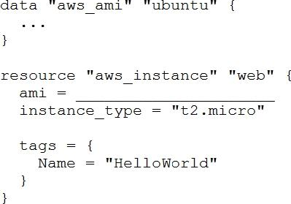
What value should you enter for the ami argument in the AWS instance resource?
aws_ami.ubuntu
data.aws_ami.ubuntu
data.aws_ami.ubuntu.id
aws_ami.ubuntu.id
29. The terraform.tfstate file always matches your currently built infrastructure.
True
False
30. What is not processed when running a terraform refresh?
State file
Configuration file
Credentials
Cloud provider
31. What type of block is used to construct a collection of nested configuration blocks?
for_each
repeated
nesting
dynamic
32. How is terraform import run?
As a part of terraform init
As a part of terraform plan
As a part of terraform refresh
By an explicit call
All of the above
33. When using Terraform to deploy resources into Azure, which scenarios are true regarding state files? (Choose two.)
When a change is made to the resources via the Azure Cloud Console, the changes are recorded in a new state file
When a change is made to the resources via the Azure Cloud Console, Terraform will update the state file to reflect them during the next plan or apply
When a change is made to the resources via the Azure Cloud Console, the current state file will not be updated
When a change is made to the resources via the Azure Cloud Console, the changes are recorded in the current state file
34. When using a module block to reference a module stored on the public Terraform Module Registry such as:
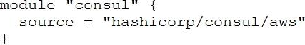
How do you specify version 1.0.0?
Modules stored on the public Terraform Module Registry do not support versioning
Append ?ref=v1.0.0 argument to the source path
Add version = "1.0.0" attribute to module block
Nothing C modules stored on the public Terraform Module Registry always default to version 1.0.0
35. A Terraform provider is not responsible for:
Understanding API interactions with some service
Provisioning infrastructure in multiple clouds
Exposing resources and data sources based on an API
Managing actions to take based on resource differences
36. Which of the following is allowed as a Terraform variable name?
count
name
source
version
37. You have never used Terraform before and would like to test it out using a shared team account for a cloud provider. The shared team account already contains 15 virtual machines (VM). You develop a Terraform configuration containing one VM, perform terraform apply, and see that your VM was created successfully.
What should you do to delete the newly-created VM with Terraform?
The Terraform state file contains all 16 VMs in the team account. Execute terraform destroy and select the newly-created V
The Terraform state file only contains the one new V
Execute terraform destroy.
Delete the Terraform state file and execute Terraform apply.
Delete the VM using the cloud provider console and terraform apply to apply the changes to the Terraform state file.
38. How can terraform plan aid in the development process?
Validates your expectations against the execution plan without permanently modifying state
Initializes your working directory containing your Terraform configuration files
Formats your Terraform configuration files
Reconciles Terraform’s state against deployed resources and permanently modifies state using the current status of deployed resources
39. Which backend does the Terraform CLI use by default?
Terraform Cloud
Consul
Remote
Local
40. When does terraform apply reflect changes in the cloud environment?
Immediately
However long it takes the resource provider to fulfill the request
After updating the state file
Based on the value provided to the -refresh command line argument
None of the above
41. When you initialize Terraform, where does it cache modules from the public Terraform Module Registry?
On disk in the /tmp directory
In memory
On disk in the .terraform sub-directory
They are not cached
42. A terraform apply can not _________ infrastructure.
change
destroy
provision
import
43. What information does the public Terraform Module Registry automatically expose about published modules?
Required input variables
Optional inputs variables and default values
Outputs
All of the above
None of the above
44. Terraform can only manage resource dependencies if you set them explicitly with the depends_on argument.
True
False
45. When running the command terraform taint against a managed resource you want to force recreation upon, Terraform will immediately destroy and recreate the resource.
True
False
46. How is the Terraform remote backend different than other state backends such as S3, Consul, etc.?
It can execute Terraform runs on dedicated infrastructure on premises or in Terraform Cloud
It doesn't show the output of a terraform apply locally
It is only available to paying customers
All of the above
47. You need to deploy resources into two different cloud regions in the same Terraform configuration.
To do that, you declare multiple provider configurations as follows:
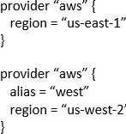
What meta-argument do you need to configure in a resource block to deploy the resource to the “us-west-2” AWS region?
alias = west
provider = west
provider = aws.west
alias = aws.west
48. Where in your Terraform configuration do you specify a state backend?
The terraform block
The resource block
The provider block
The datasource block
49. Which of the following is not a valid Terraform collection type?
list
map
tree
set
50. A Terraform provisioner must be nested inside a resource configuration block.
True
False
51. Where does the Terraform local backend store its state?
In the /tmp directory
In the terraform.tfvars file
In the terraform.tfstate file
In the user's .terraformrc file
52. Terraform variables and outputs that set the "description" argument will store that description in the state file.
True
False
53. Module variable assignments are inherited from the parent module and do not need to be explicitly set.
True
False
54. If you manually destroy infrastructure, what is the best practice reflecting this change in Terraform?
Run terraform refresh
It will happen automatically
Manually update the state fire
Run terraform import
55. All standard backend types support state storage, locking, and remote operations like plan.
apply and destroy.
True
False
56. What command does Terraform require the first time you run it within a configuration directory?
terraform import
terraform init
terraform plan
terraform workspace
57. Which task does terraform init not perform?
Sources all providers present in the configuration and ensures they are downloaded and available locally
Connects to the backend
Sources any modules and copies the configuration locally
Validates all required variables are present
58. Terraform can run on Windows or Linux, but it requires a Server version of the Windows operating system.
True
False
59. What is terraform refresh intended to detect?
Terraform configuration code changes
Empty state files
State file drift
Corrupt state files
60. Which of the following is available only in Terraform Enterprise or Cloud workspaces and not in Terraform CLI?
Secure variable storage
Support for multiple cloud providers
Dry runs with terraform plan
Using the workspace as a data source
61. CORRECT TEXT
FILL BLANK
What is the name of the default file where Terraform stores the state?
Type your answer in the field provided. The text field is not case-sensitive and all variations of the correct answer are accepted. terraform.tfstate
62. Which of these is the best practice to protect sensitive values in state files?
Blockchain
Secure Sockets Layer (SSL)
Enhanced remote backends
Signed Terraform providers
63. You have deployed a new webapp with a public IP address on a clod provider. However, you did not create any outputs for your code.
What is the best method to quickly find the IP address of the resource you deployed?
Run terraform output ip_address to view the result
In a new folder, use the terraform_remote_state data source to load in the state file, then write an output for each resource that you find the state file
Run terraform state list to find the name of the resource, then terraform state show to find the attributes including public IP address
Run terraform destroy then terraform apply and look for the IP address in stdout
64. CORRECT TEXT
FILL BLANK
Which flag would you add to terraform plan to save the execution plan to a file?
Type your answer in the field provided. The text field is not case-sensitive and all variations of the correct answer are accepted. terraform plan -out=tfplan
65. You have multiple team members collaborating on infrastructure as code (IaC) using Terraform, and want to apply formatting standards for readability.
How can you format Terraform HCL (HashiCorp Configuration Language) code according to standard Terraform style convention?
Run the terraform fmt command during the code linting phase of your CI/CD process
Designate one person in each team to review and format everyone's code
Manually apply two spaces indentation and align equal sign "=" characters in every Terraform file (*.tf)
Write a shell script to transform Terraform files using tools such as AWK, Python, and sed
66. You would like to reuse the same Terraform configuration for your development and production environments with a different state file for each.
Which command would you use?
terraform import
terraform workspace
terraform state
terraform init
67. Which of the following is not an action performed by terraform init?
Create a sample main.tf file
Initialize a configured backend
Retrieve the source code for all referenced modules
Load required provider plugins
68. What is the name assigned by Terraform to reference this resource?
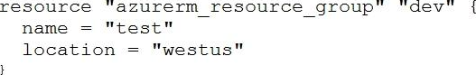
compute_instance
main
google
test
69. If a module uses a local variable, you can expose that value with a terraform output.
True
False
70. Which provisioner invokes a process on the resource created by Terraform?
remote-exec
null-exec
local-exec
file
71. HashiCorp Configuration Language (HCL) supports user-defined functions.
True
False
72. You’re building a CI/CD (continuous integration/ continuous delivery) pipeline and need to inject sensitive variables into your Terraform run.
How can you do this safely?
Pass variables to Terraform with a Cvar flag
Copy the sensitive variables into your Terraform code
Store the sensitive variables in a secure_vars.tf file
Store the sensitive variables as plain text in a source code repository
73. Terraform provisioners that require authentication can use the ______ block.
connection
credentials
secrets
ssh
74. You have recently started a new job at a retailer as an engineer. As part of this new role, you have been tasked with evaluating multiple outages that occurred during peak shopping time during the holiday season. Your investigation found that the team is manually deploying new compute instances and configuring each compute instance manually. This has led to inconsistent configuration between each compute instance.
How would you solve this using infrastructure as code?
Implement a ticketing workflow that makes engineers submit a ticket before manually provisioning and configuring a resource
Implement a checklist that engineers can follow when configuring compute instances
Replace the compute instance type with a larger version to reduce the number of required deployments
Implement a provisioning pipeline that deploys infrastructure configurations committed to your version control system following code reviews
75. In Terraform 0.13 and above, outside of the required_providers block, Terraform configurations always refer to providers by their local names.
True
False
76. What is one disadvantage of using dynamic blocks in Terraform?
They cannot be used to loop through a list of values
Dynamic blocks can construct repeatable nested blocks
They make configuration harder to read and understand
Terraform will run more slowly
77. You write a new Terraform configuration and immediately run terraform apply in the CLI using the local backend.
Why will the apply fail?
Terraform needs you to format your code according to best practices first
Terraform needs to install the necessary plugins first
The Terraform CLI needs you to log into Terraform cloud first
Terraform requires you to manually run terraform plan first
78. When should you use the force-unlock command?
You see a status message that you cannot acquire the lock
You have a high priority change
Automatic unlocking failed
Your apply failed due to a state lock
79. What is the provider for this fictitious resource?
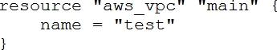
vpc
main
aws
test
80. You should store secret data in the same version control repository as your Terraform configuration.
True
False
81. Which option can not be used to keep secrets out of Terraform configuration files?
A Terraform provider
Environment variables
A -var flag
secure string
82. Why would you use the terraform taint command?
When you want to force Terraform to destroy a resource on the next apply
When you want to force Terraform to destroy and recreate a resource on the next apply
When you want Terraform to ignore a resource on the next apply
When you want Terraform to destroy all the infrastructure in your workspace
83. Setting the TF_LOG environment variable to DEBUG causes debug messages to be logged into syslog.
True
False
84. A fellow developer on your team is asking for some help in refactoring their Terraform code. As part of their application’s architecture, they are going to tear down an existing deployment managed by Terraform and deploy new. However, there is a server resource named aws_instance.ubuntu[1] they would like to keep to perform some additional analysis.
What command should be used to tell Terraform to no longer manage the resource?
terraform apply rm aws_instance.ubuntu[1]
terraform state rm aws_instance.ubuntu[1]
terraform plan rm aws_instance.ubuntu[1]
terraform delete aws_instance.ubuntu[1]
85. Which two steps are required to provision new infrastructure in the Terraform workflow? (Choose two.)
Destroy
Apply
Import
Init
Validate
86. Which of the following is the correct way to pass the value in the variable num_servers into a module with the input servers?
servers = num_servers
servers = variable.num_servers
servers = var(num_servers)
servers = var.num_servers
87. Which statement describes a goal of infrastructure as code?
An abstraction from vendor specific APIs
Write once, run anywhere
A pipeline process to test and deliver software
The programmatic configuration of resources
88. What value does the Terraform Cloud/Terraform Enterprise private module registry provide over the public Terraform Module Registry?
The ability to share modules with public Terraform users and members of Terraform Enterprise Organizations
The ability to tag modules by version or release
The ability to restrict modules to members of Terraform Cloud or Enterprise organizations
The ability to share modules publicly with any user of Terraform
89. You need to constrain the GitHub provider to version 2.1 or greater.
Which of the following should you put into the Terraform 0.12 configuration’s provider block?
version >= 2.1
version ~> 2.1
version = “<= 2.1”
version = “>= 2.1”
90. CORRECT TEXT
FILL BLANK
You need to specify a dependency manually.
What resource meta-parameter can you use to make sure Terraform respects the dependency? depends_on
Type your answer in the field provided. The text field is not case-sensitive and all variations of the correct answer are accepted.
91. A provider configuration block is required in every Terraform configuration.
Example:
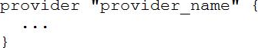
True
False
92. Your DevOps team is currently using the local backend for your Terraform configuration. You would like to move to a remote backend to begin storing the state file in a central location.
Which of the following backends would not work?
Amazon S3
Artifactory
Git
Terraform Cloud
93. What features stops multiple admins from changing the Terraform state at the same time?
Version control
Backend types
Provider constraints
State locking
94. You have a simple Terraform configuration containing one virtual machine (VM) in a cloud provider. You run terraform apply and the VM is created successfully.
What will happen if you delete the VM using the cloud provider console, and run terraform apply again without changing any Terraform code?
Terraform will remove the VM from state file
Terraform will report an error
Terraform will not make any changes
Terraform will recreate the VM
95. In contrast to Terraform Open Source, when working with Terraform Enterprise and Cloud Workspaces, conceptually you could think about them as completely separate working directories.
True
False
96. You have provisioned some virtual machines (VMs) on Google Cloud Platform (GCP) using the gcloud command line tool. However, you are standardizing with Terraform and want to manage these VMs using Terraform instead.
What are the two things you must do to achieve this? (Choose two.)
Provision new VMs using Terraform with the same VM names
Use the terraform import command for the existing VMs
Write Terraform configuration for the existing VMs
Run the terraform import-gcp command
97. Which of the following is not a key principle of infrastructure as code?
Versioned infrastructure
Golden images
Idempotence
Self-describing infrastructure
98. Which of the following is not true of Terraform providers?
Providers can be written by individuals
Providers can be maintained by a community of users
Some providers are maintained by HashiCorp
Major cloud vendors and non-cloud vendors can write, maintain, or collaborate on Terraform providers
None of the above
99. How would you reference the "name" value of the second instance of this fictitious resource?
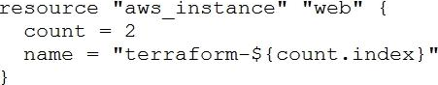
element(aws_instance.web, 2)
aws_instance.web[1].name
aws_instance.web[1]
aws_instance.web[2].name
aws_instance.web.*.name
100. terraform init initializes a sample main.tf file in the current directory.
True
False

